Claude Certified Architect - Practice Questions
This document preserves the original screenshots to avoid inventing question text. The correct option is written below each screenshot and wrapped in double quotes.
Verification note: The provided folder contains 66 image files with duplicate screenshots for several questions. Visible question numbers 51 and 53 were not present in the supplied images, so no missing question text was fabricated.

Image 01 - Question 1
Source image: image-1776406351640.jpg
Correct option: "B. Launch a fresh subagent with a summary of prior findings."
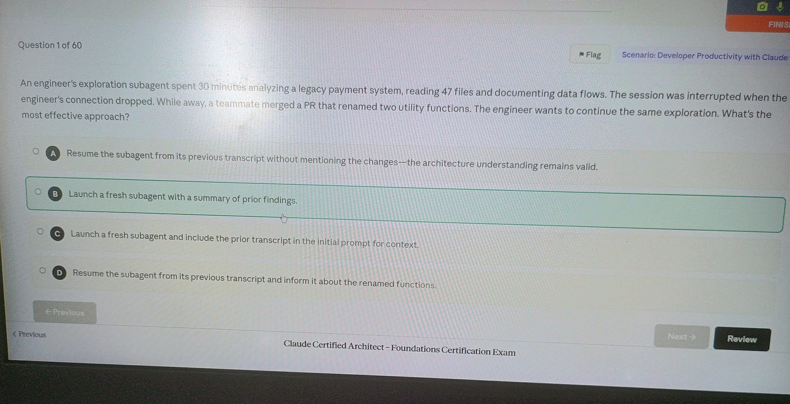

Image 02 - Question 2
Source image: image-1776406456761.jpg
Correct option: "D. Read the library and wrapper modules to identify all exposed names for the function, then Grep for each name across the codebase."
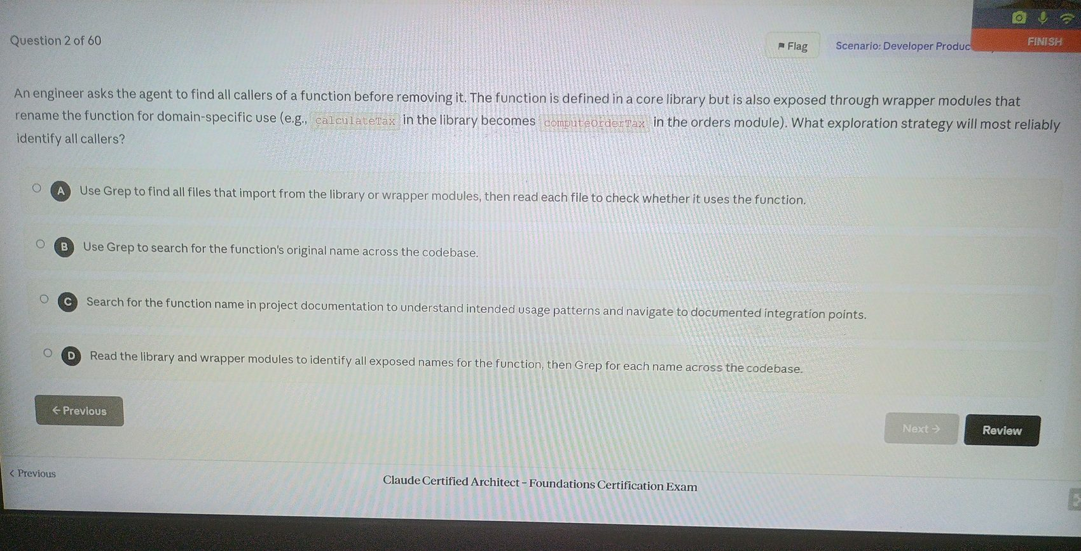

Image 03 - Question 3
Source image: image-1776406507508.jpg
Correct option: "C. Tools from all configured MCP servers are discovered at connection time and available simultaneously to the agent."
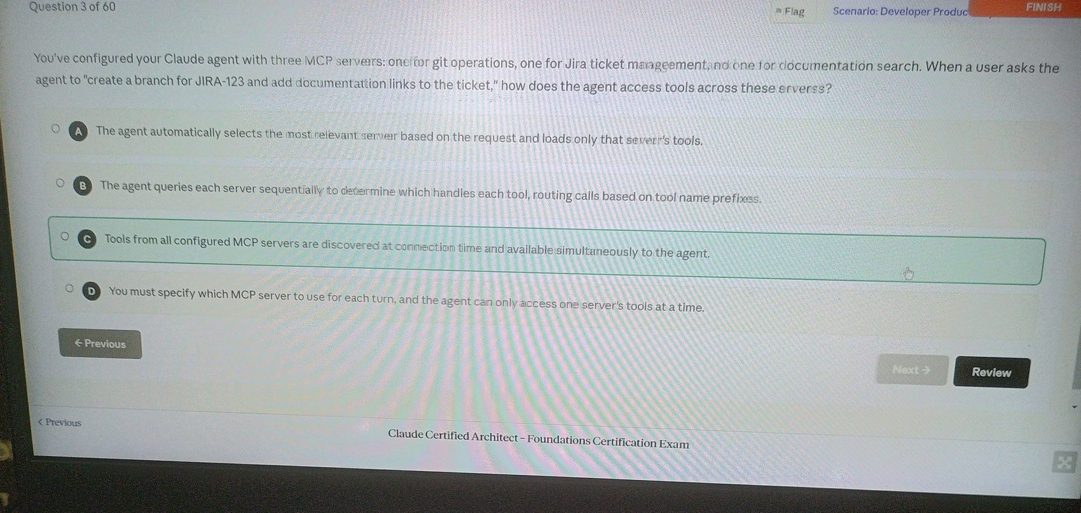

Image 04 - Question 4
Source image: image-1776406540542.jpg
Correct option: "C. Use fork_session to create two branches from yesterday's analysis, exploring one approach in each fork."
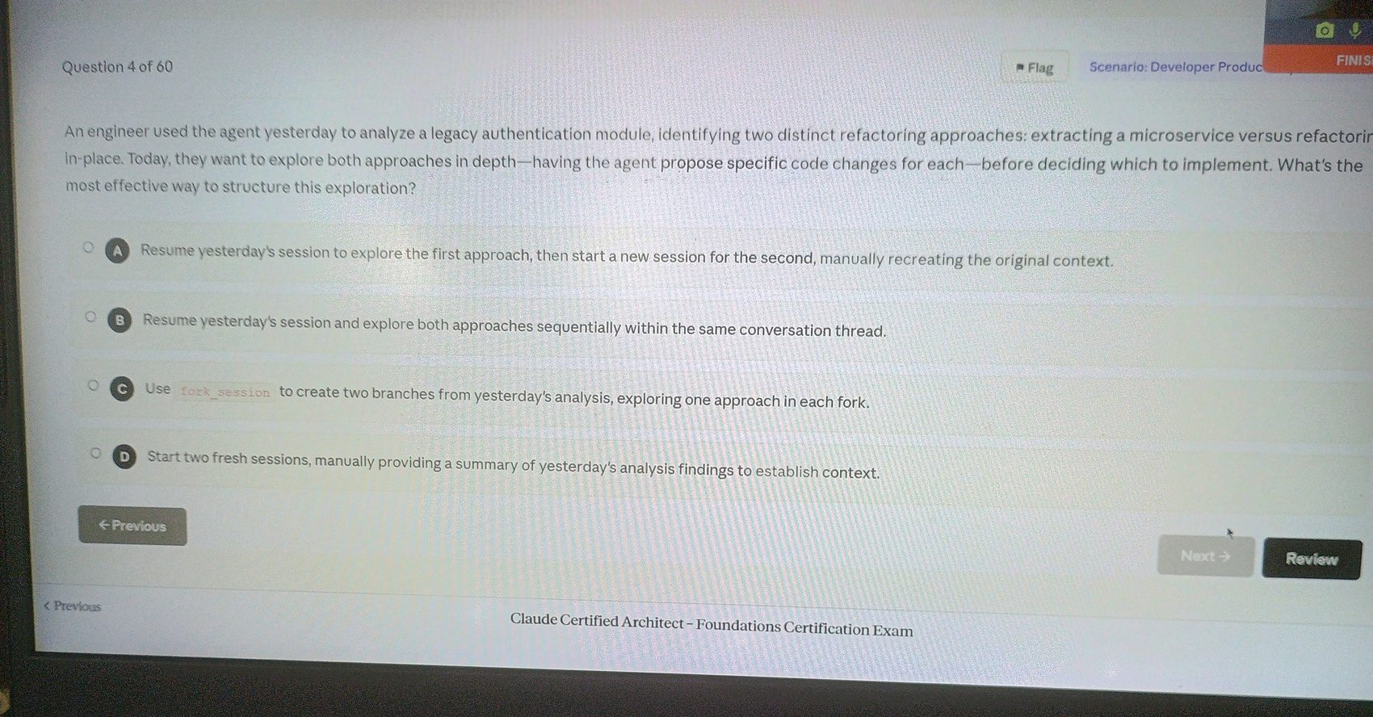

Image 05 - Question 5
Source image: image-1776406565368.jpg
Correct option: "D. Have the agent maintain a scratchpad file that records key findings, referencing it for subsequent questions."
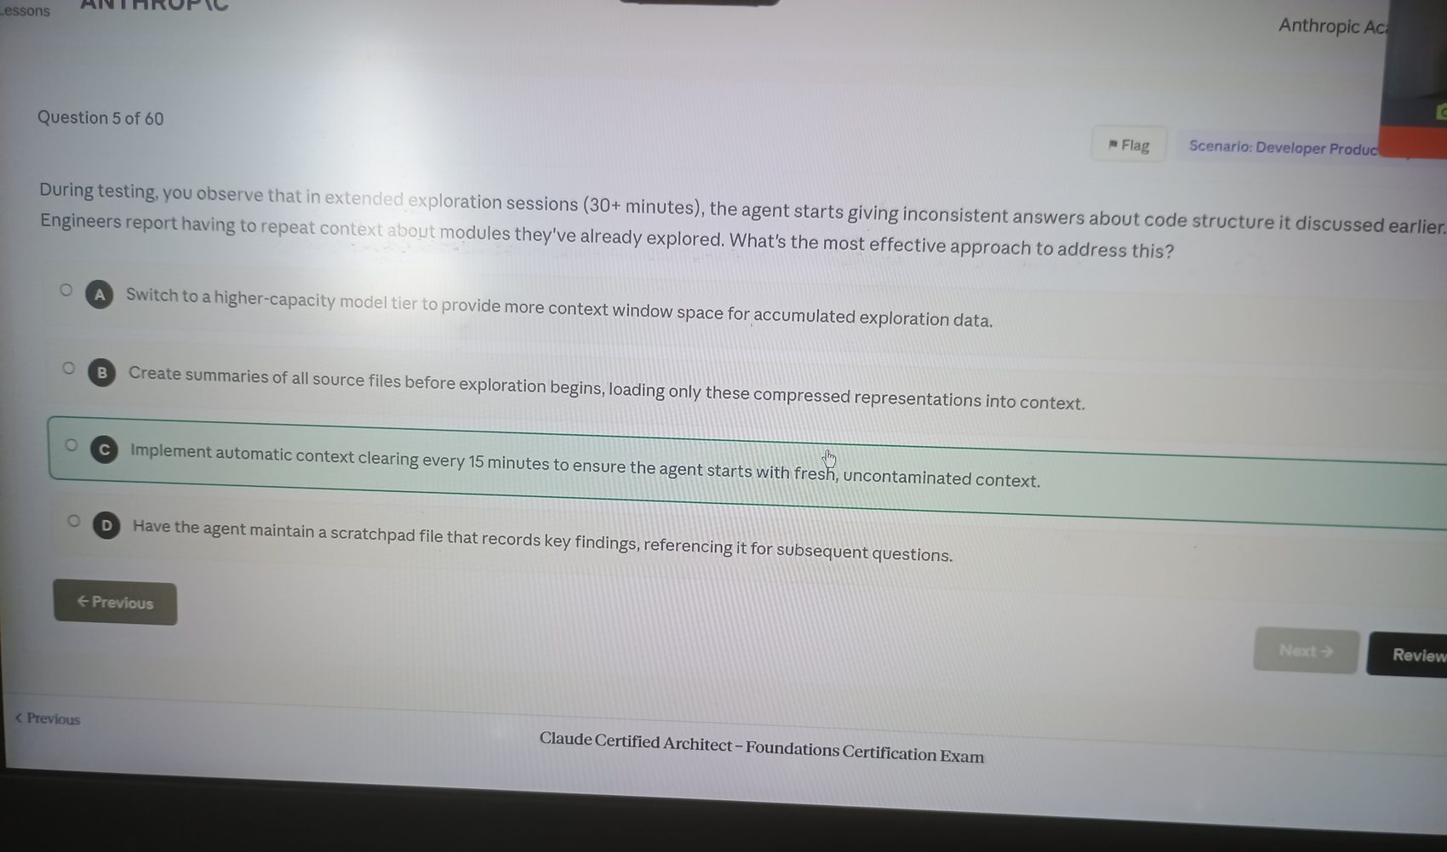

Image 06 - Question 5
Source image: image-1776406583178.jpg
Correct option: "D. Have the agent maintain a scratchpad file that records key findings, referencing it for subsequent questions."
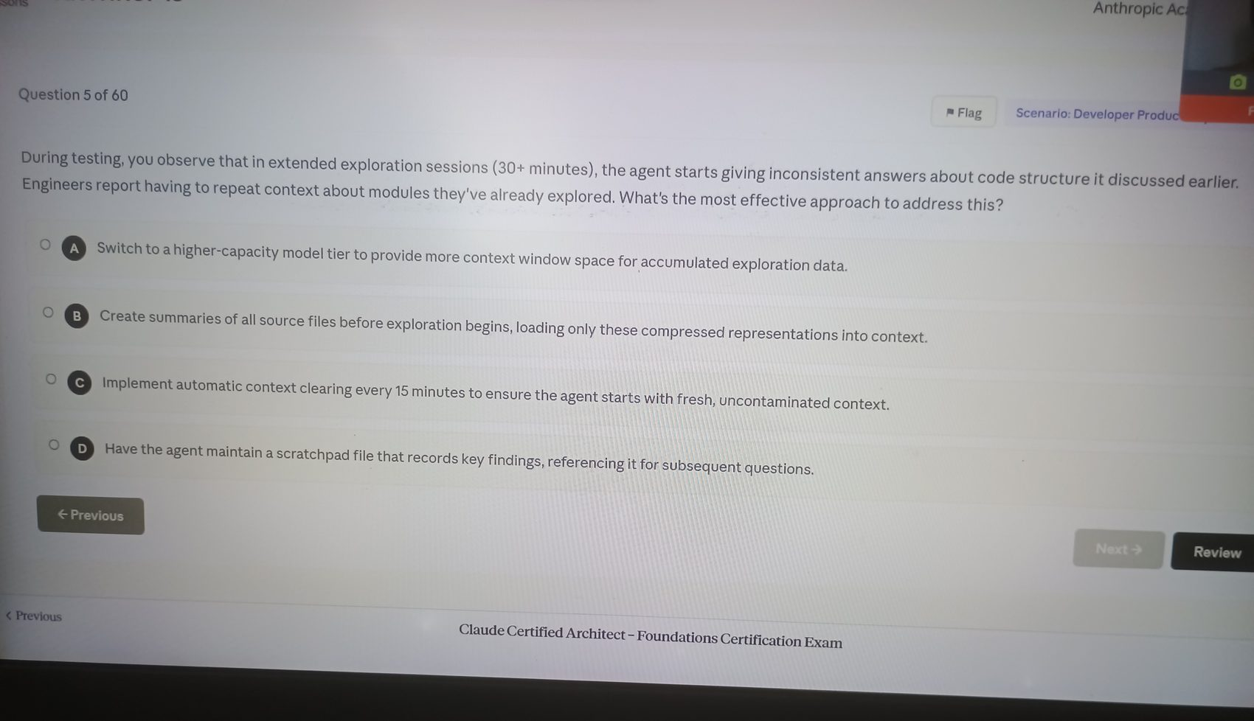

Image 07 - Question 6
Source image: image-1776406600703.jpg
Correct option: "D. Integrate an existing Jira MCP server that exposes tickets, comments, and metadata through discoverable tool interfaces."
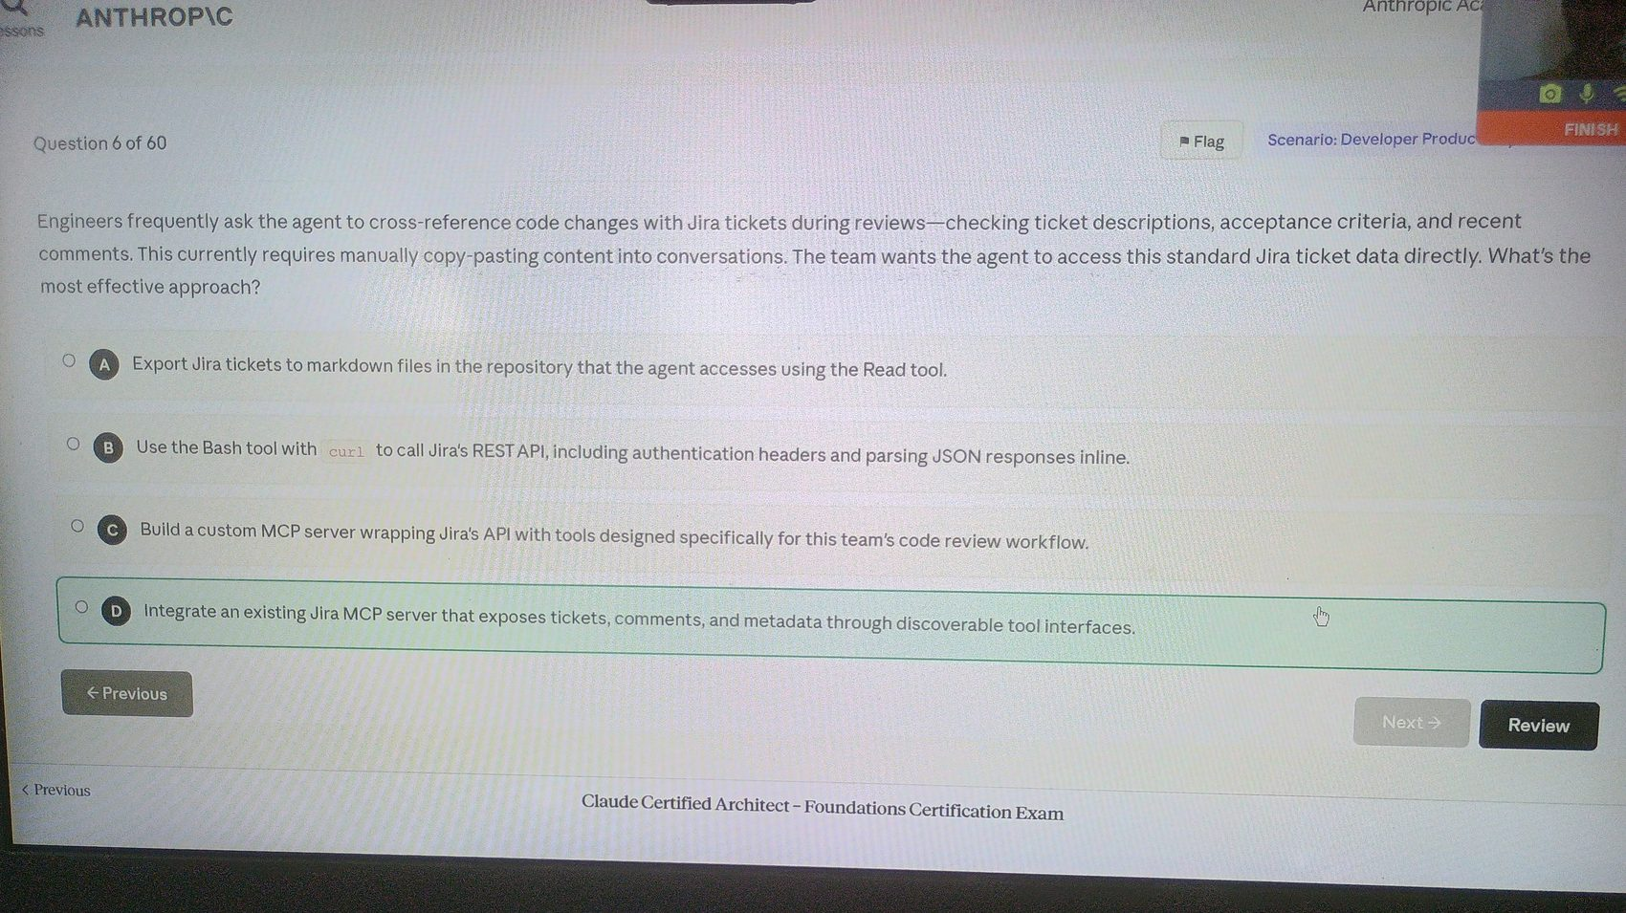

Image 08 - Question 7
Source image: image-1776406633678.jpg
Correct option: "C. Resume the analysis session with fork_session enabled, creating a separate branch for each testing strategy."
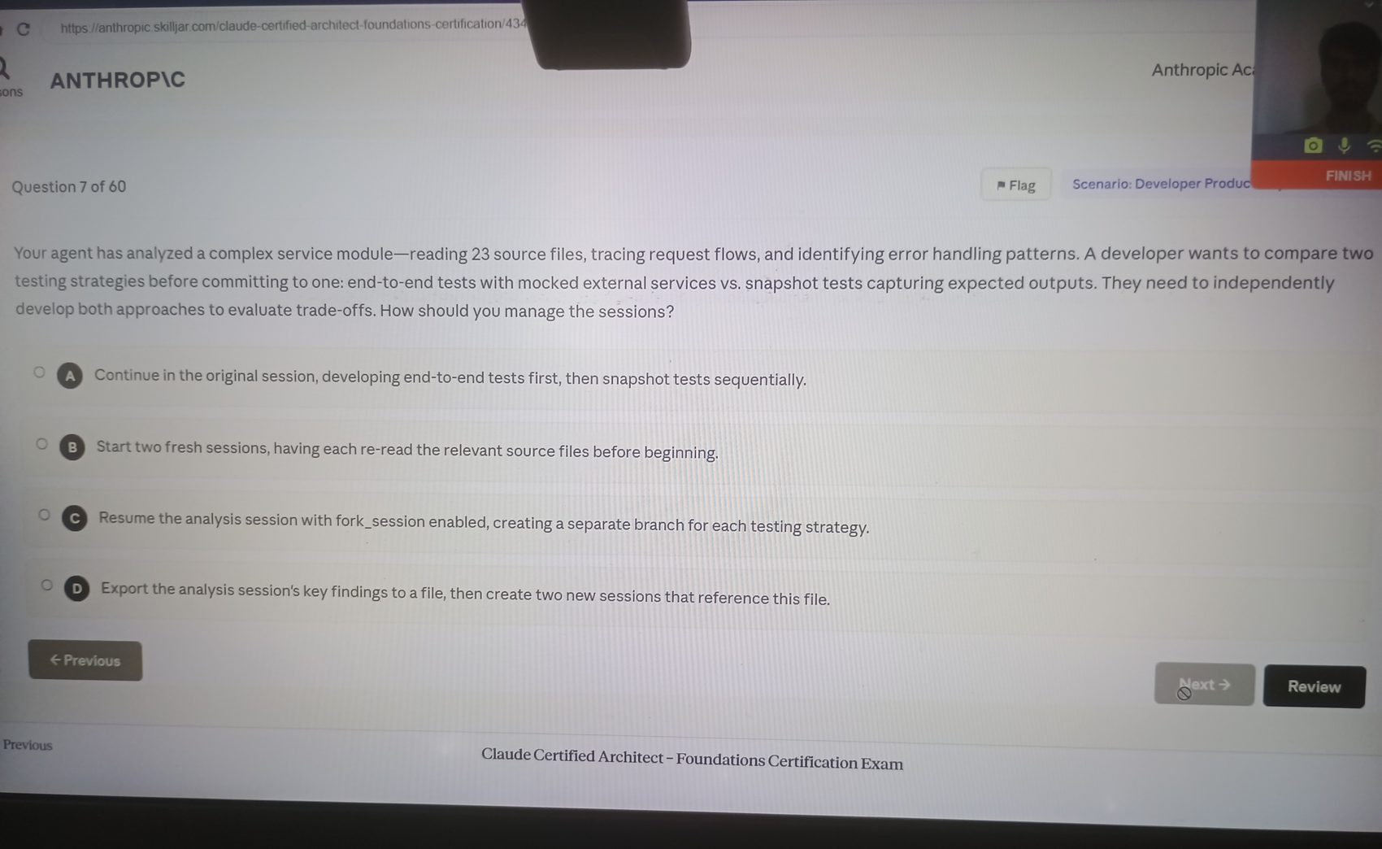

Image 09 - Question 8
Source image: image-1776406683112.jpg
Correct option: "B. Enhance the MCP tool descriptions to explain when each tool is preferable to text manipulation and clarify expected inputs and outputs."
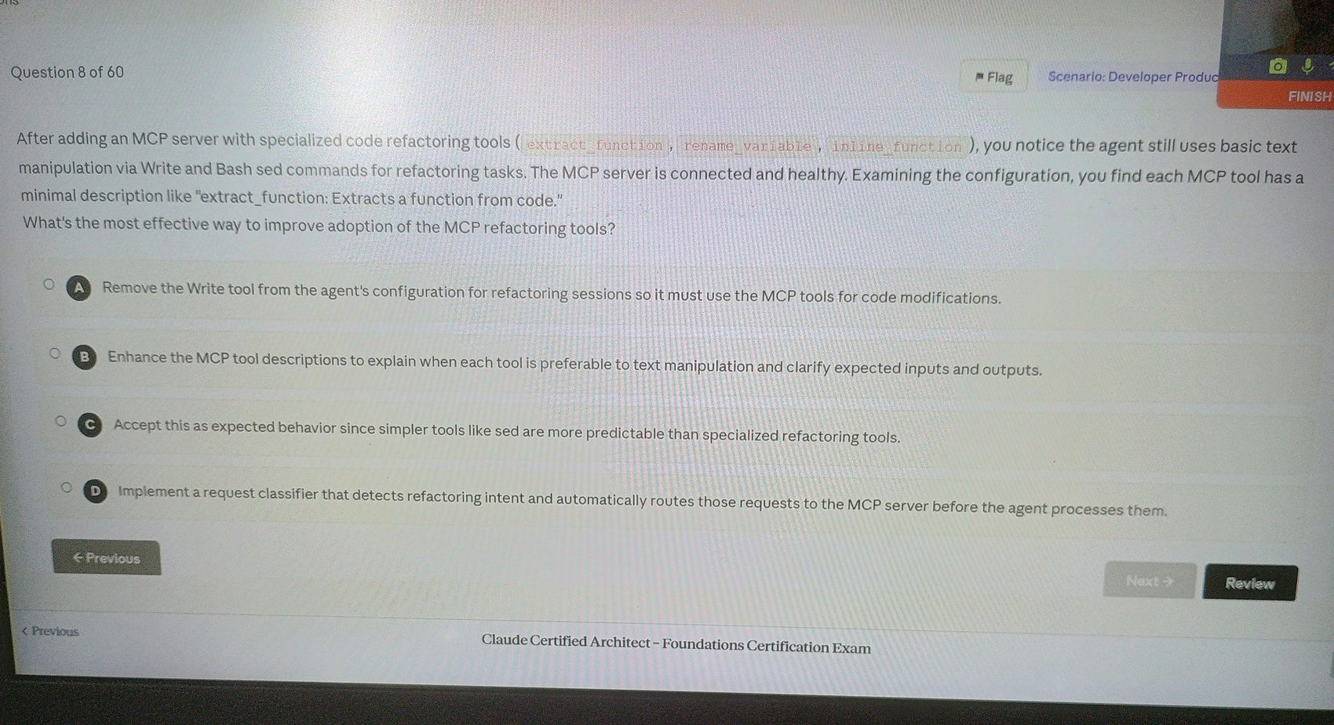

Image 10 - Question 9
Source image: image-1776406716317.jpg
Correct option: "C. Grep, to search for the import statement pattern across file contents."
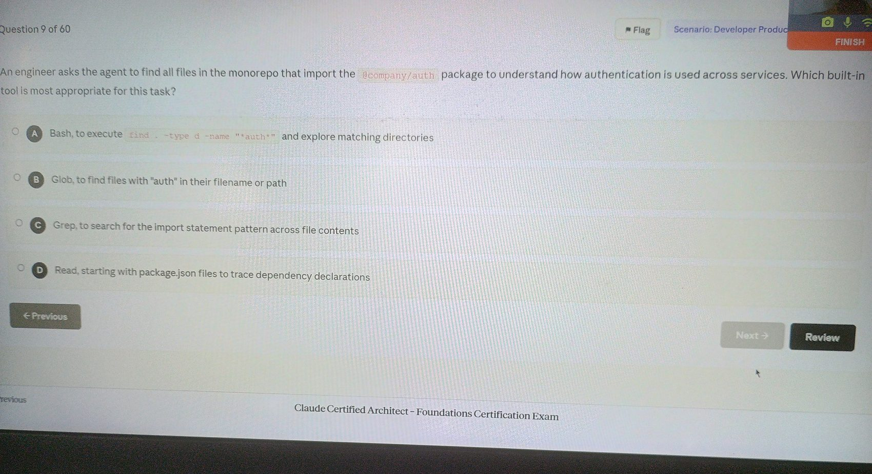

Image 11 - Question 10
Source image: image-1776406743631.jpg
Correct option: "B. Expose each server's content catalog as MCP resources - issue summaries, documentation hierarchy, database schemas."
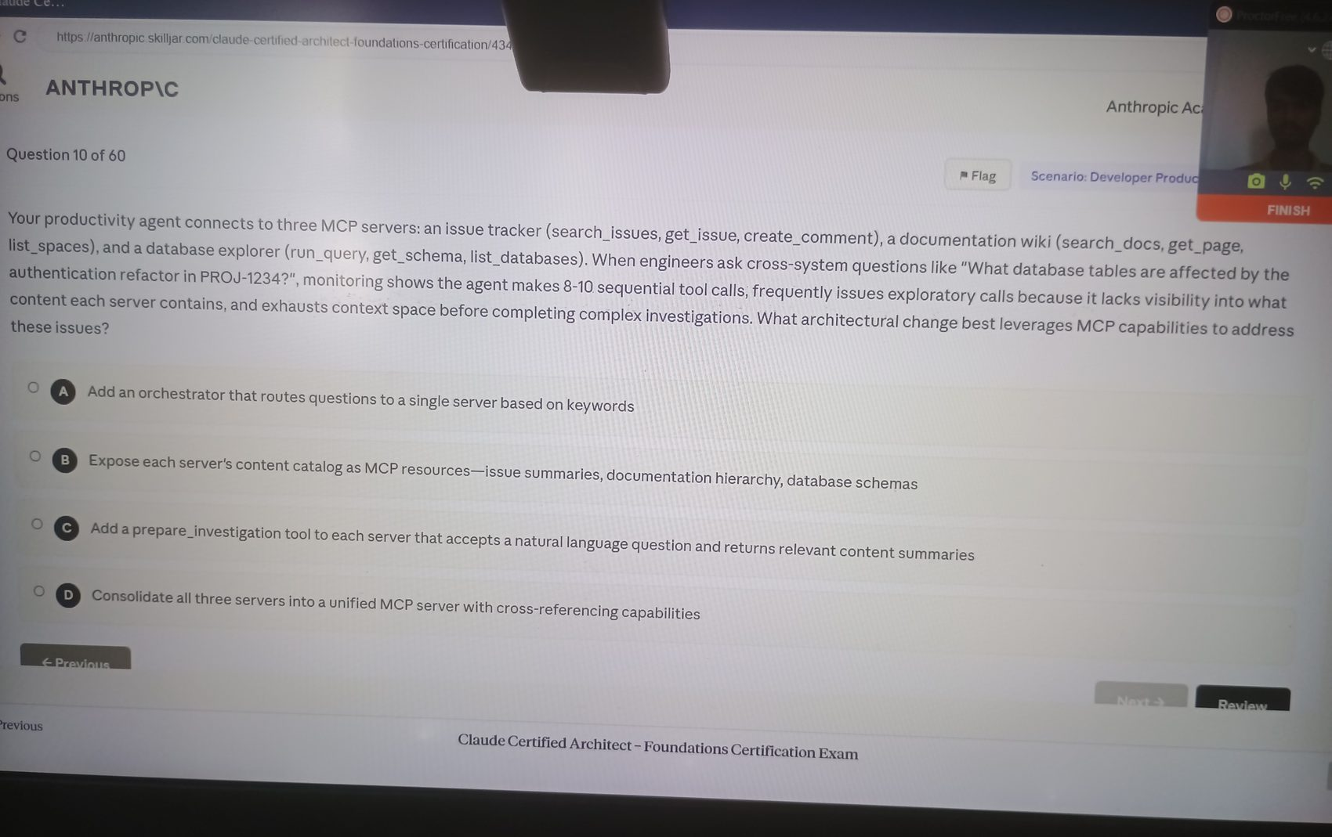

Image 12 - Question 11
Source image: image-1776406771179.jpg
Correct option: "A. Use Grep to search for distinctive text from the error message, then Read the matching files to understand context."
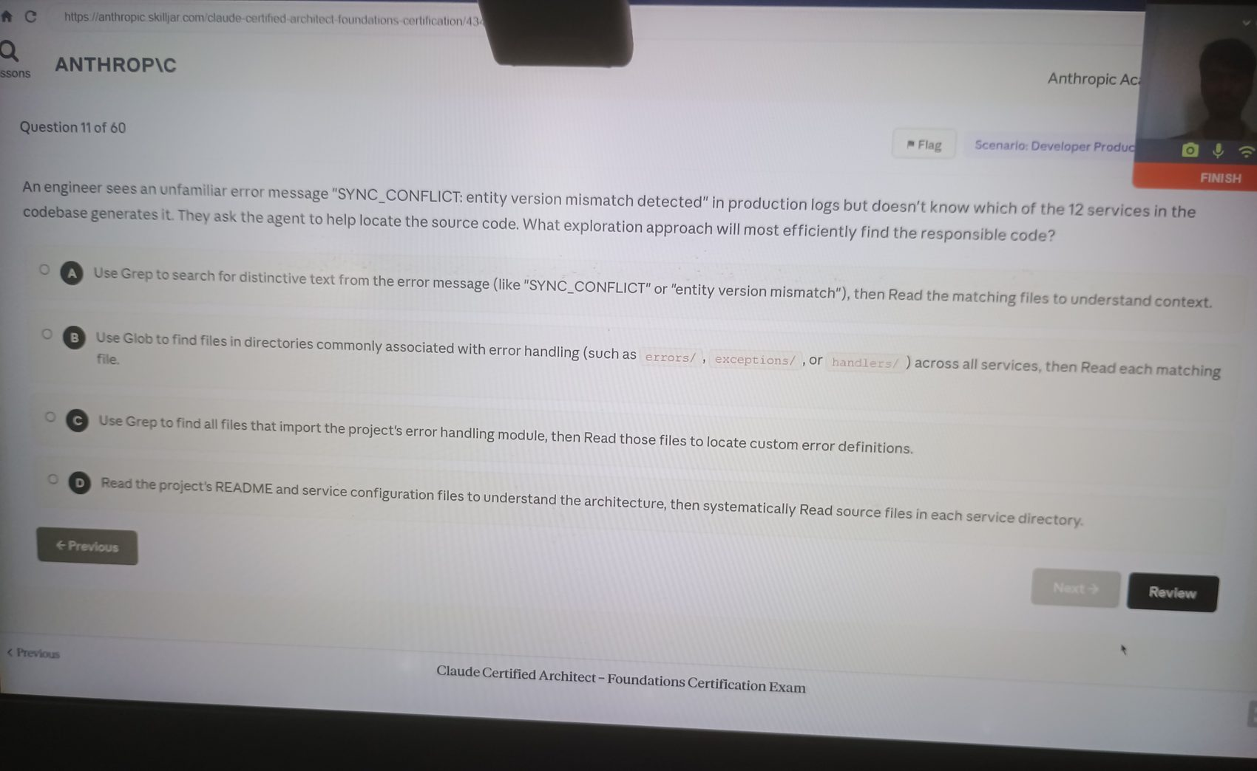

Image 13 - Question 11
Source image: image-1776406785367.jpg
Correct option: "A. Use Grep to search for distinctive text from the error message, then Read the matching files to understand context."
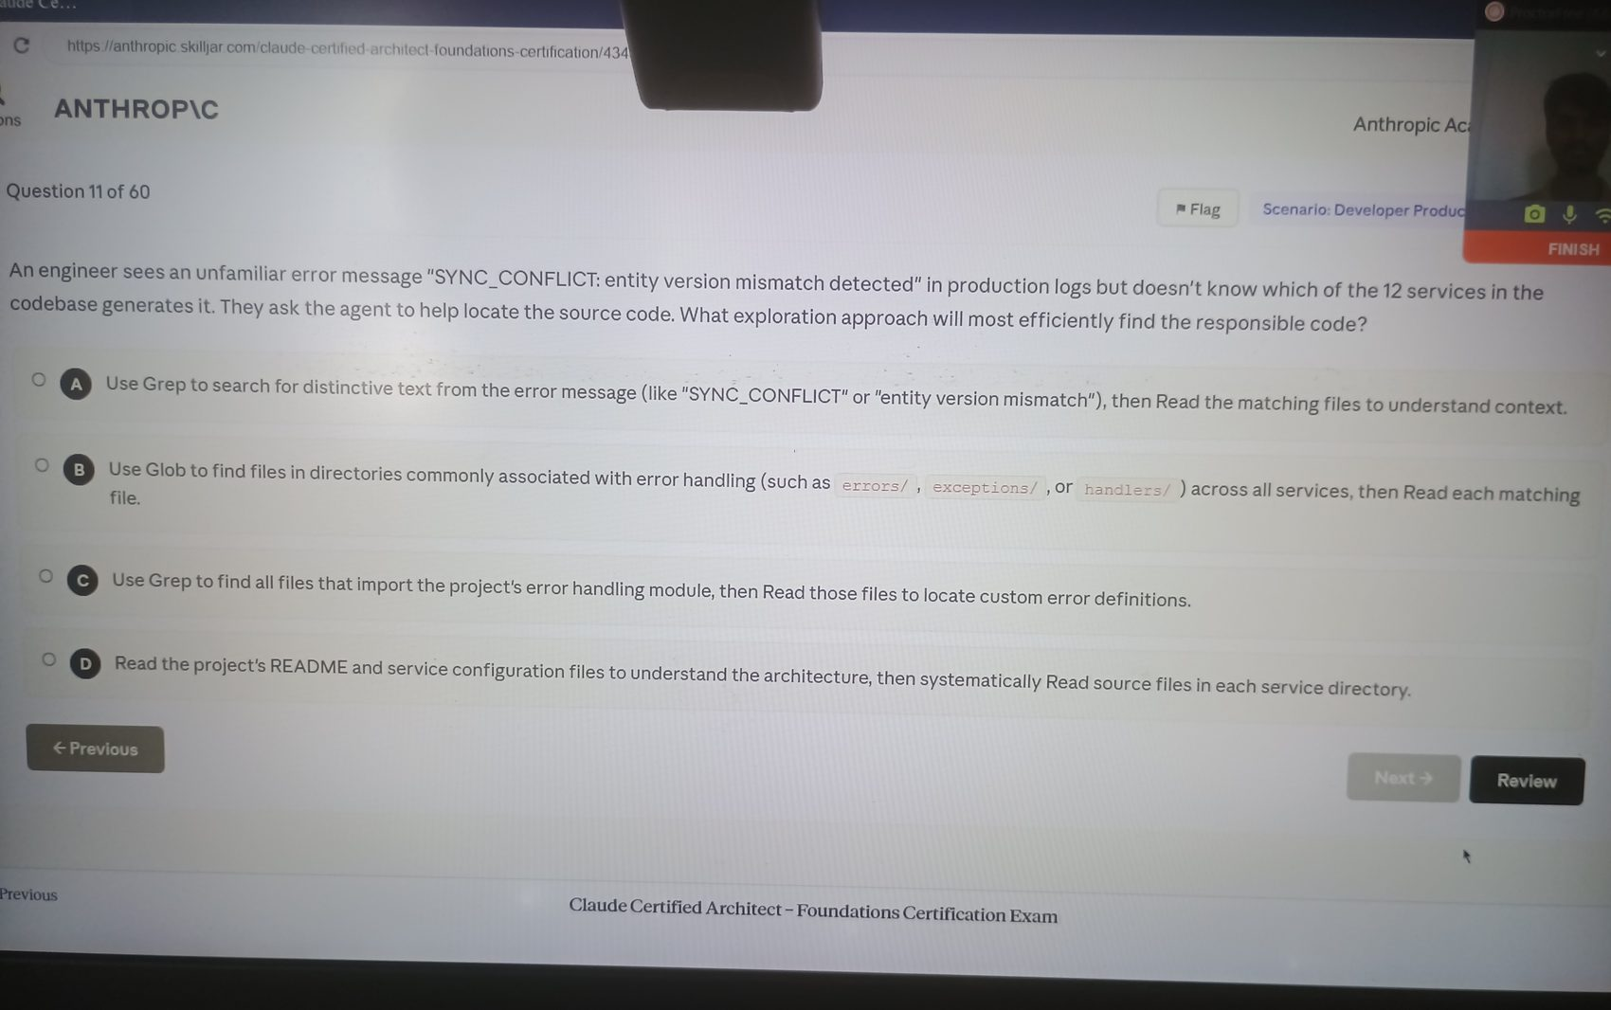

Image 14 - Question 12
Source image: image-1776406848045.jpg
Correct option: "D. Resume the session and inform the agent which specific files changed for targeted re-analysis."
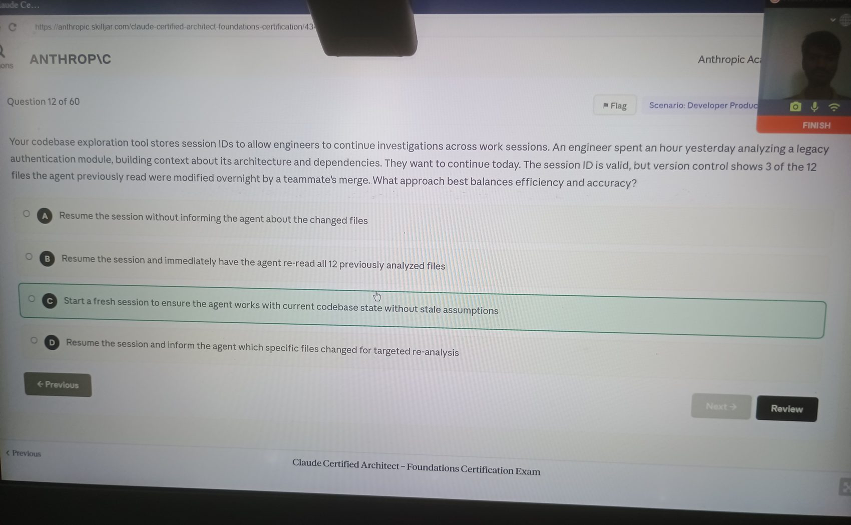

Image 15 - Question 13
Source image: image-1776406884283.jpg
Correct option: "D. Use Grep to search for the pattern "eval(" across all files in the codebase."
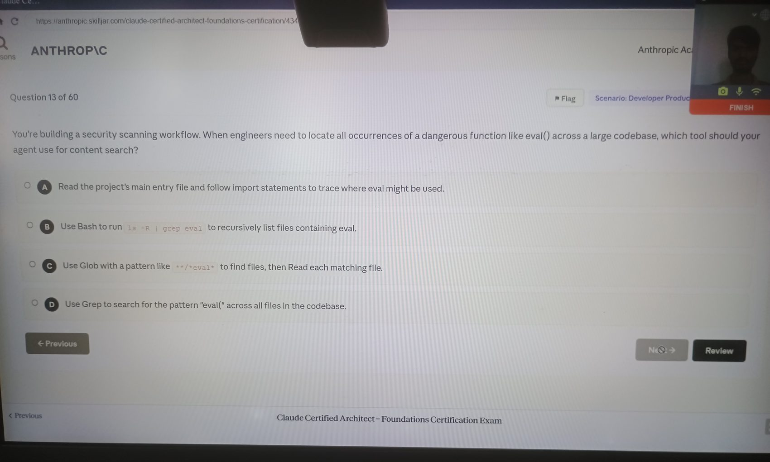

Image 16 - Question 14
Source image: image-1776406915907.jpg
Correct option: "B. Analyze imports and class hierarchies to identify the base cache class, Read that file to understand the interface, then trace specific invalidation implementations."
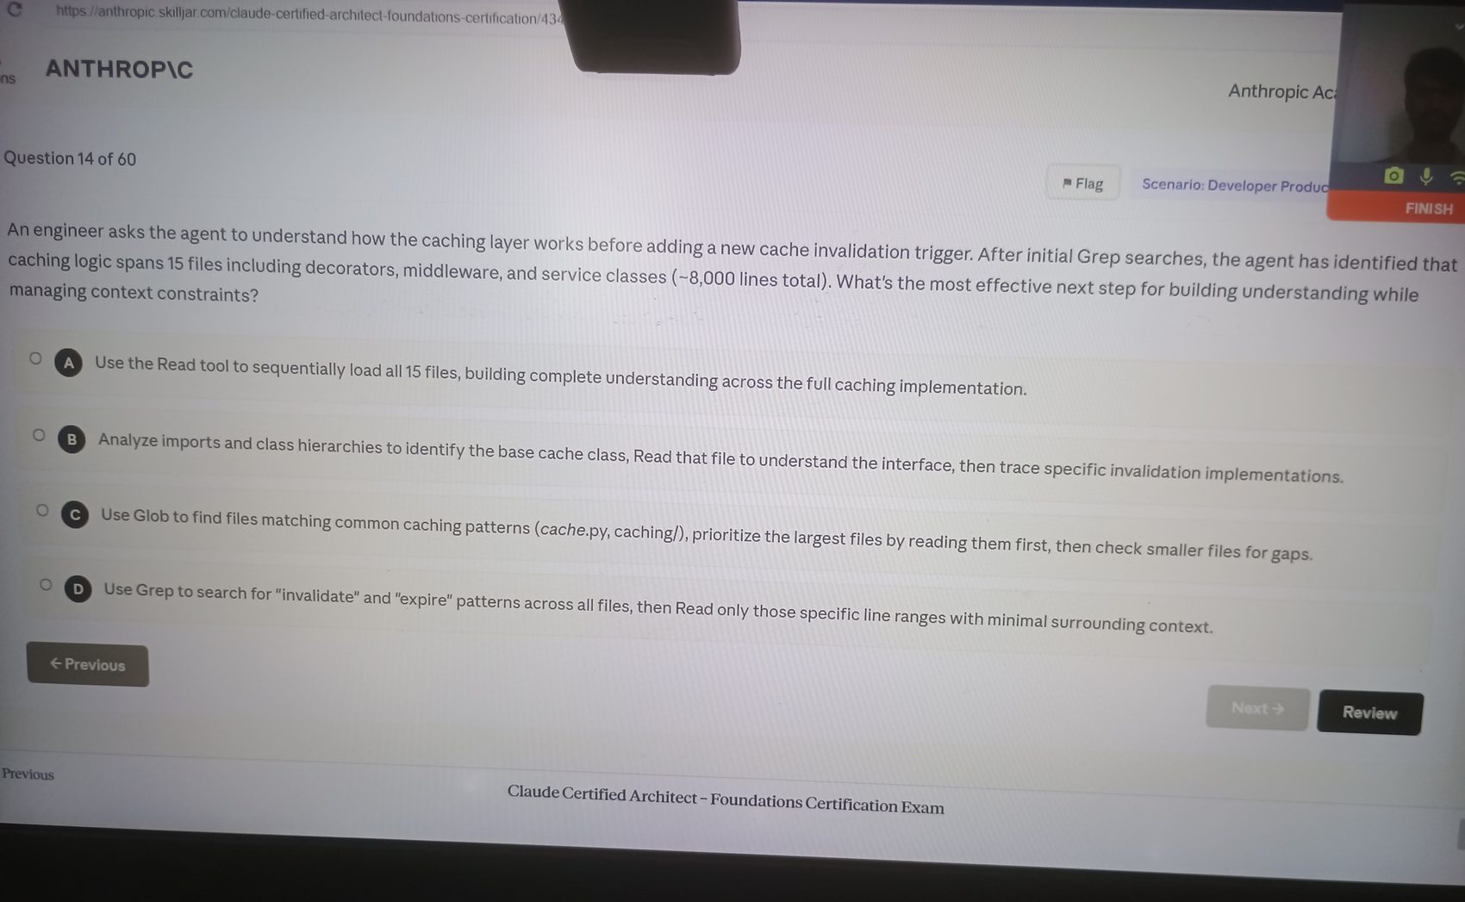

Image 17 - Question 15
Source image: image-1776406944536.jpg
Correct option: "B. Summarize key rendering findings, then spawn a sub-agent for physics exploration with that summary in its initial context."
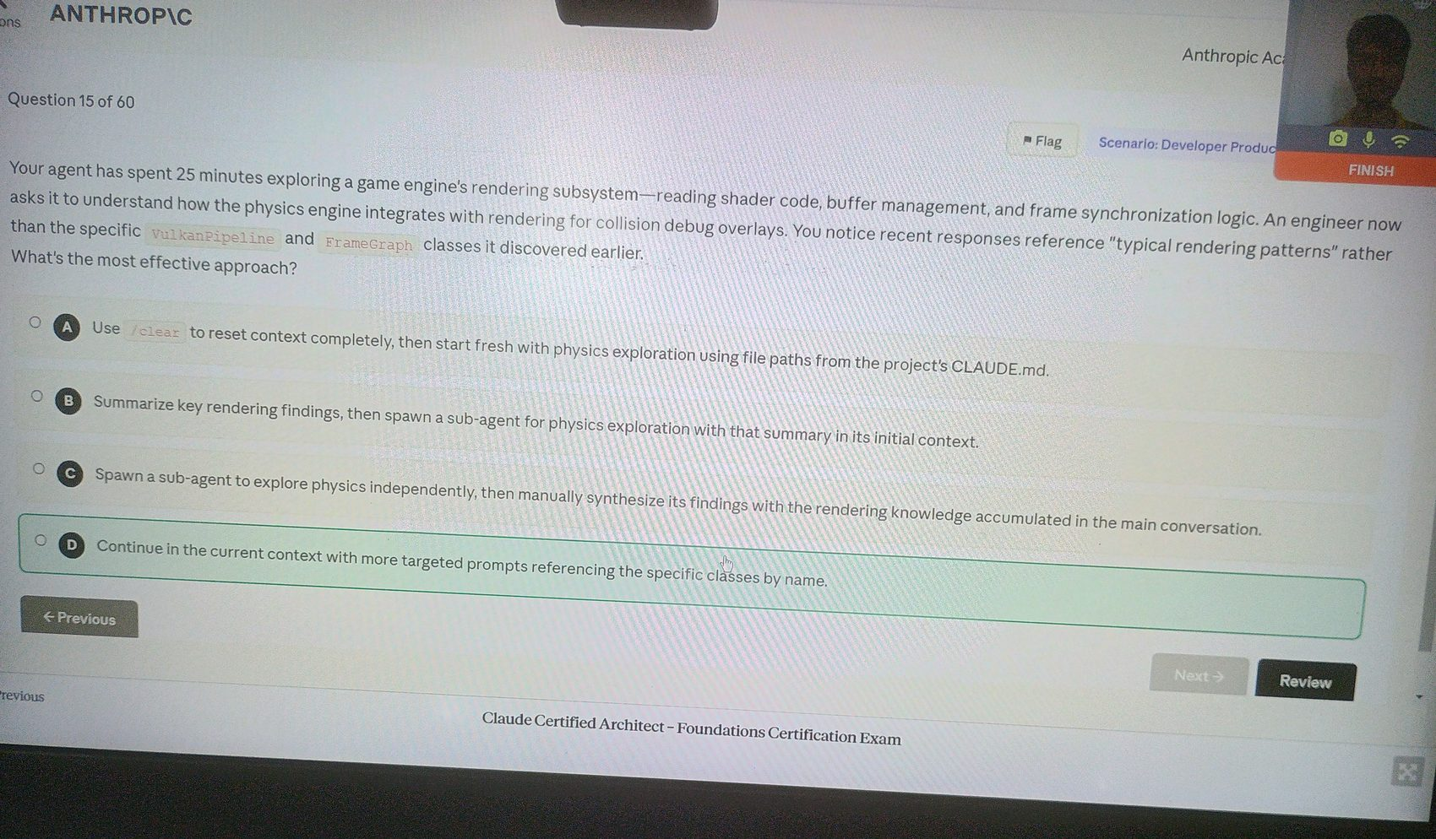

Image 18 - Question 16
Source image: image-1776406968082.jpg
Correct option: "B. Have the coordinator review analysis output for gap indicators and re-invoke search with gap-informed queries when gaps are detected."
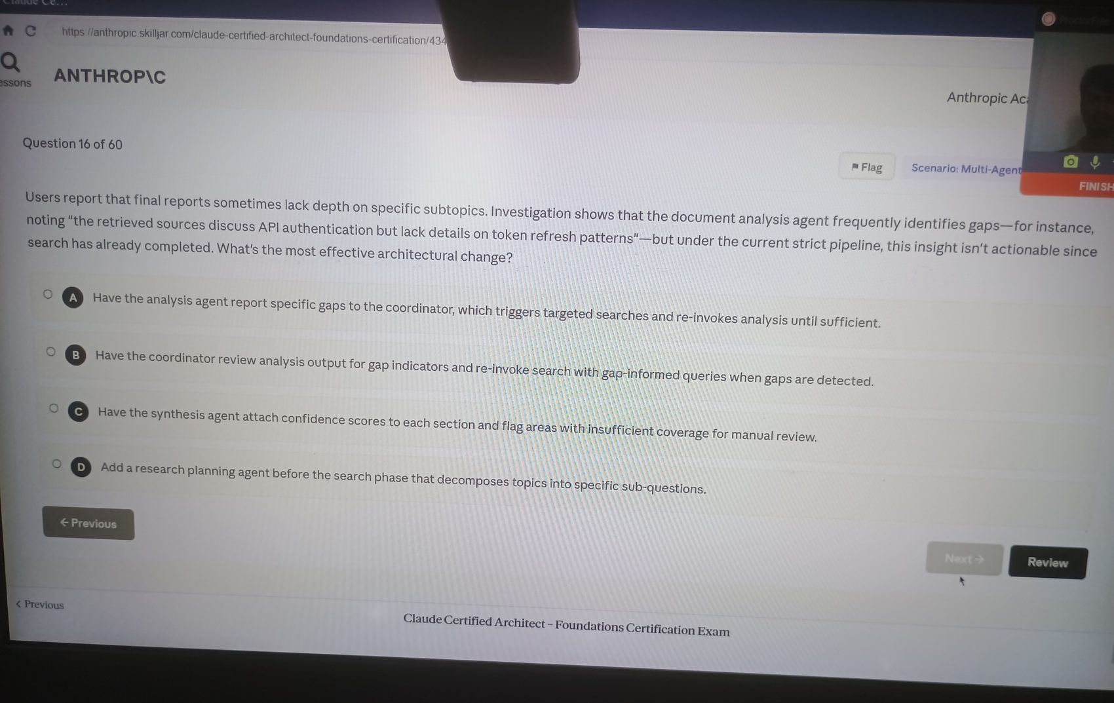

Image 19 - Question 17
Source image: image-1776406985095.jpg
Correct option: "A. Require subagents to include publication or data collection dates in their structured outputs."
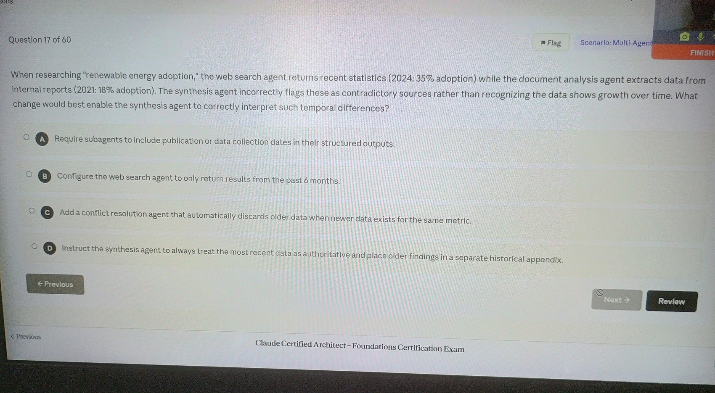

Image 20 - Question 18
Source image: image-1776407006352.jpg
Correct option: "A. Structure the coordinator to emit both Task tool calls in a single response message rather than across separate conversation turns."
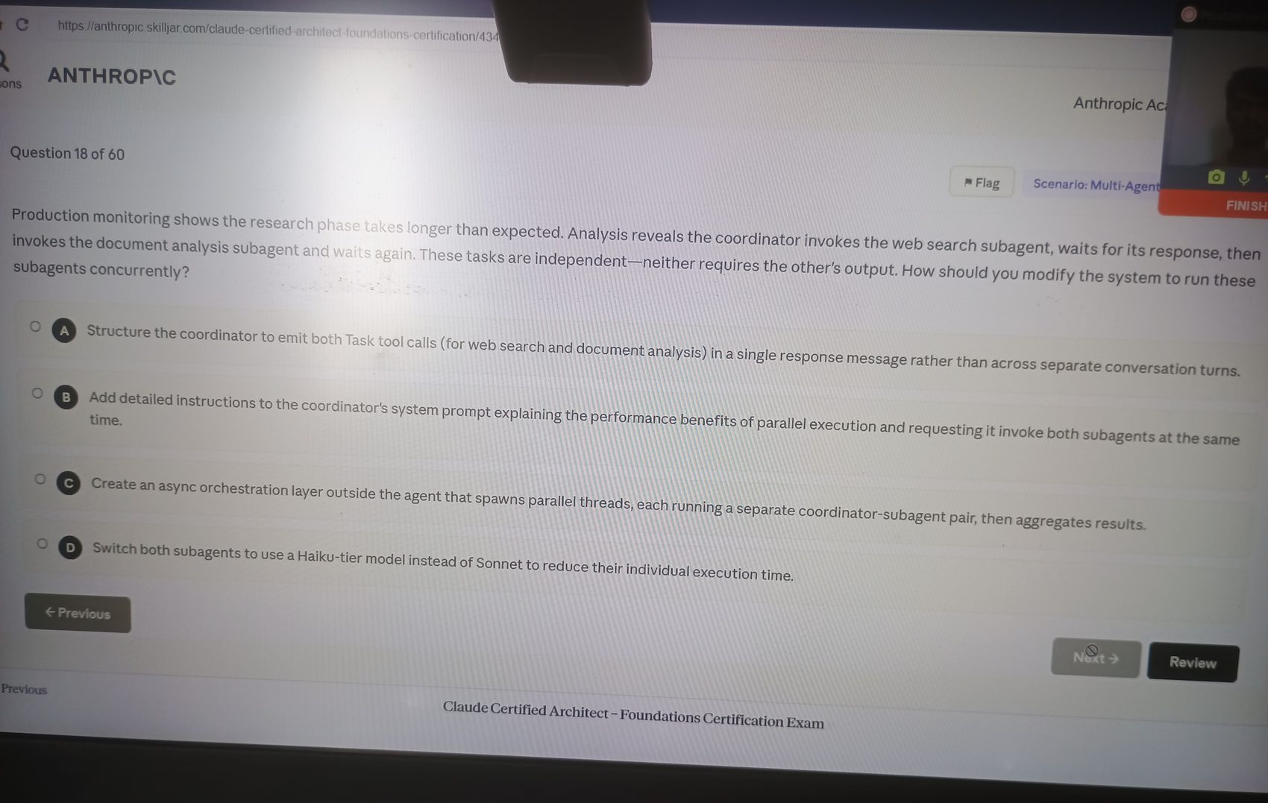

Image 21 - Question 19
Source image: image-1776407027412.jpg
Correct option: "C. Have the coordinator analyze each query and dynamically decide which subagents to invoke based on its assessment of query requirements."
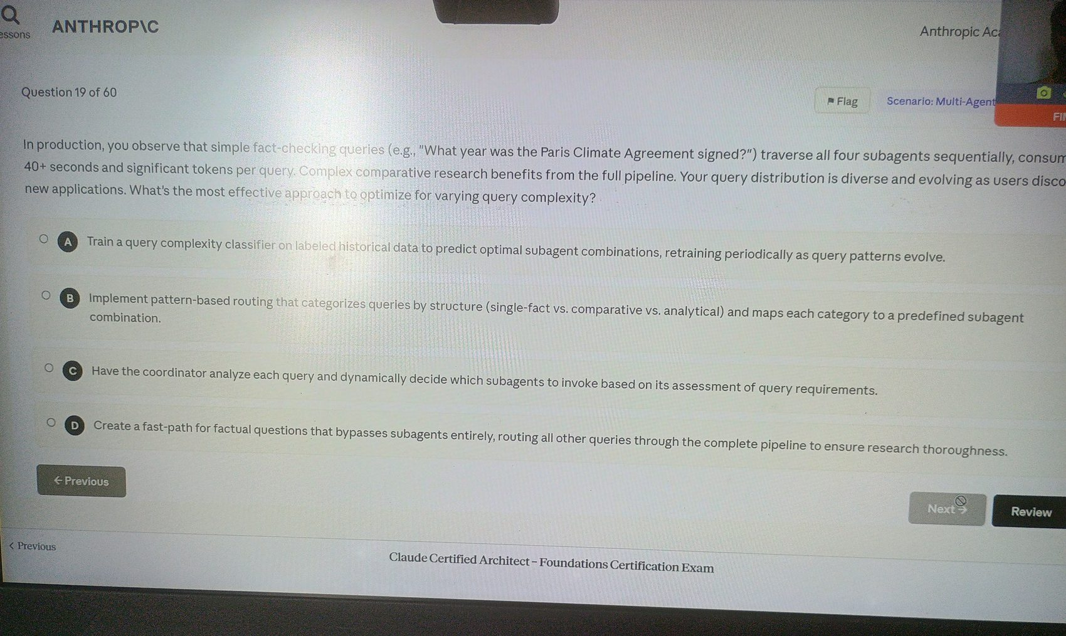

Image 22 - Question 20
Source image: image-1776407056762.jpg
Correct option: "B. Require all subagents to output structured claim-source mappings that the synthesis agent must preserve and merge when combining findings from multiple sources."
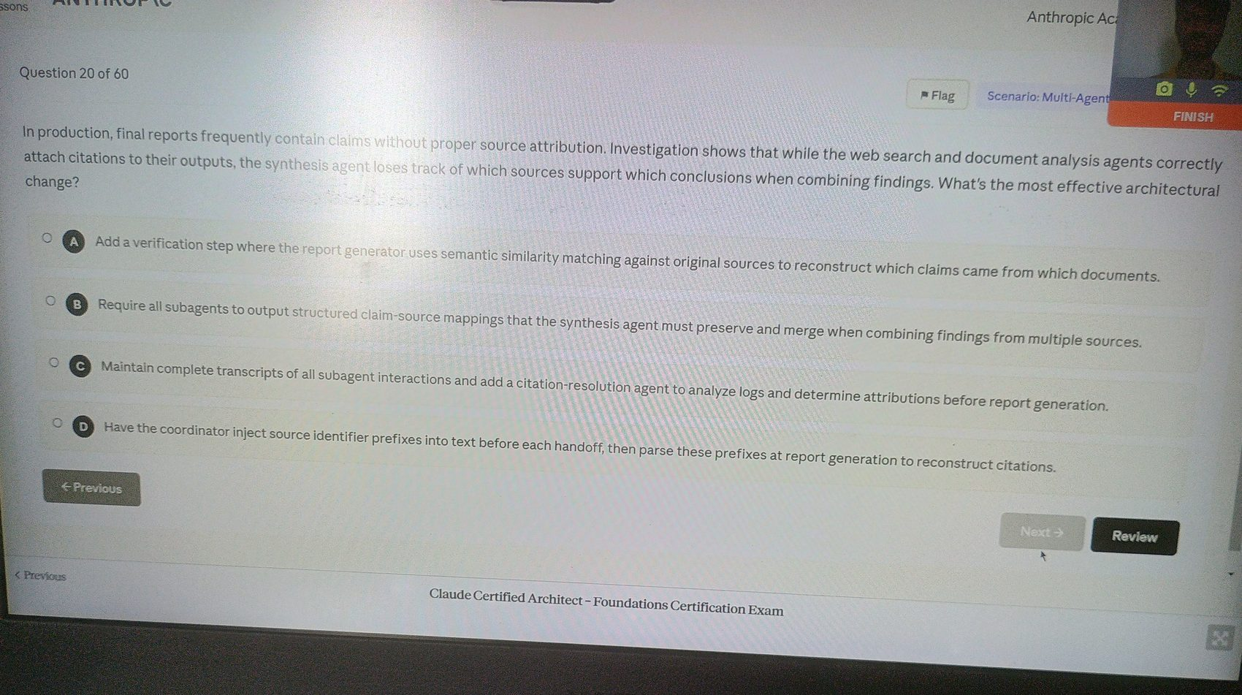

Image 23 - Question 21
Source image: image-1776407083855.jpg
Correct option: "D. Have the coordinator evaluate synthesis output for gaps, then re-delegate to web search and document analysis with targeted queries before invoking synthesis again."
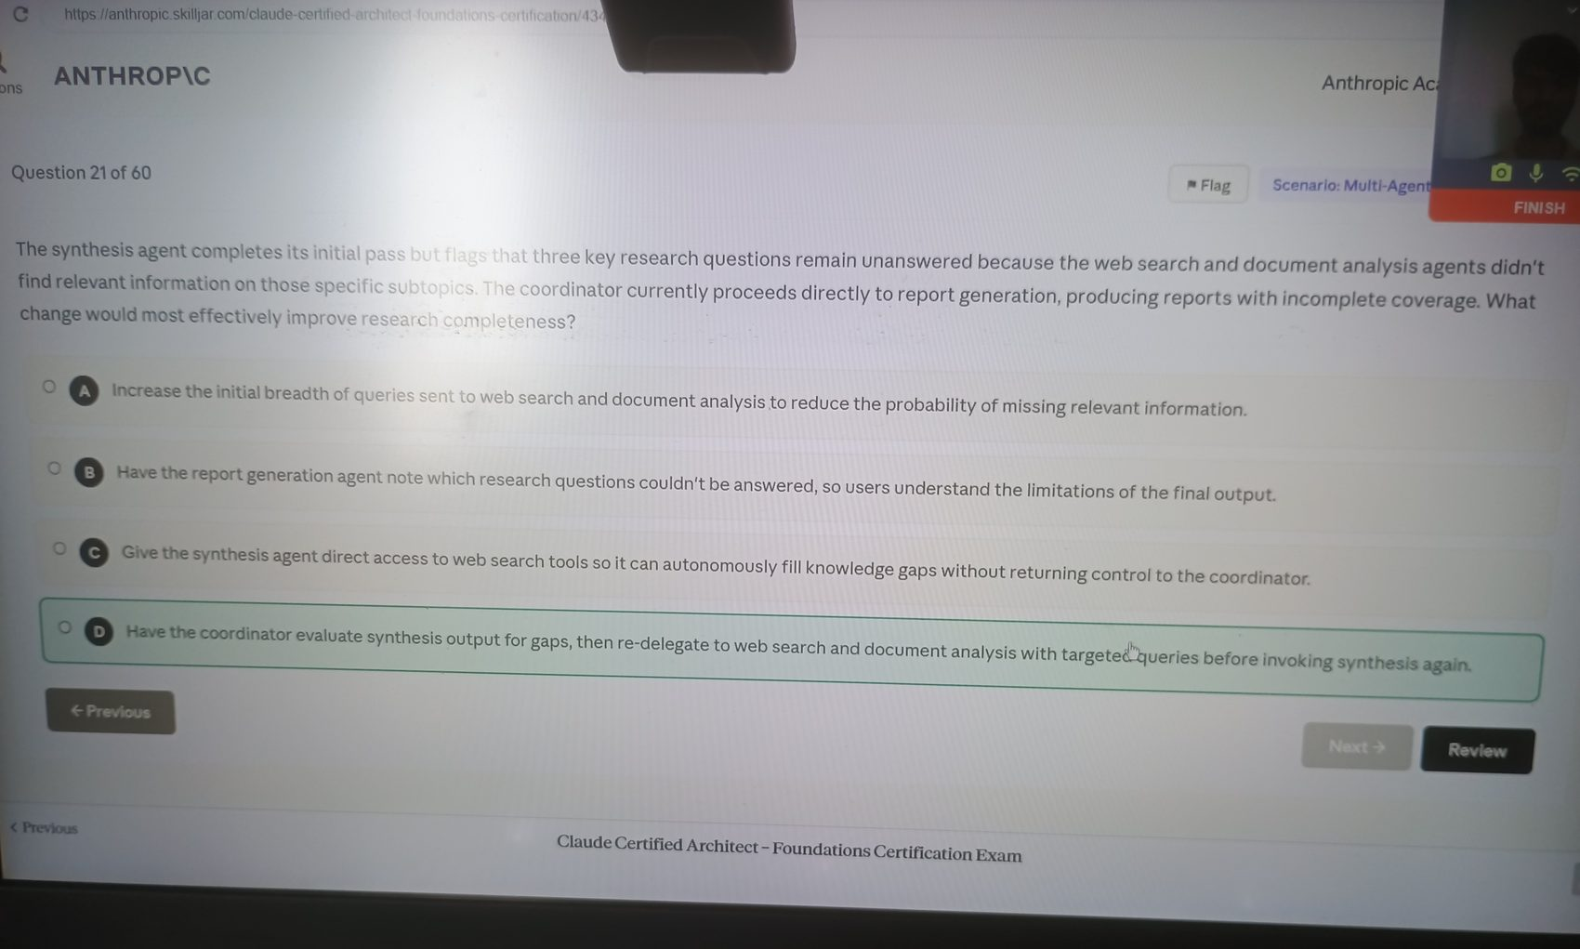

Image 24 - Question 22
Source image: image-1776407103557.jpg
Correct option: "C. Have each agent persist a structured export to a known location. On resume, the coordinator loads the manifest and injects relevant state into agent prompts."
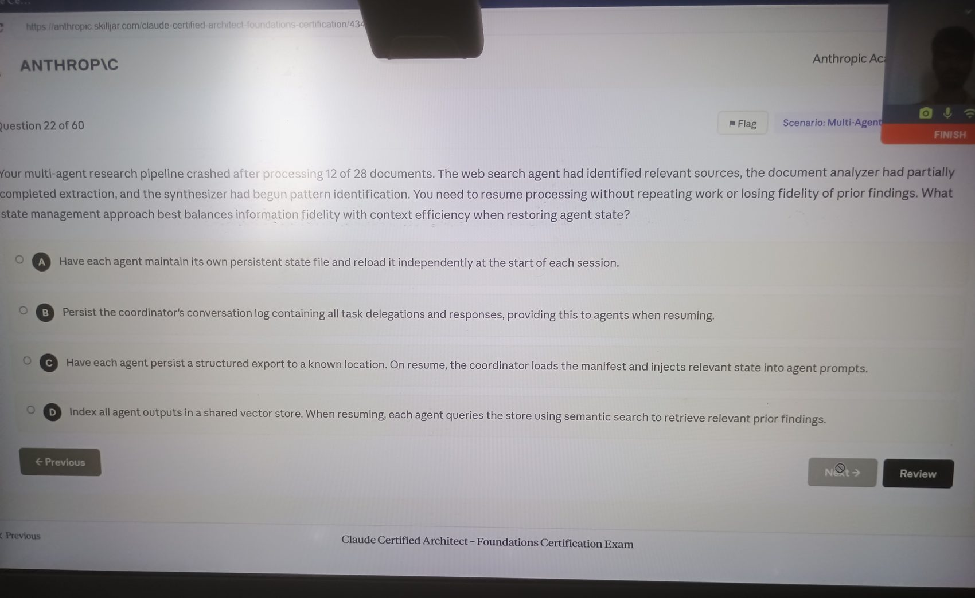

Image 25 - Question 23
Source image: image-1776407125032.jpg
Correct option: "B. Have each agent output structured data separating content summaries from source metadata."
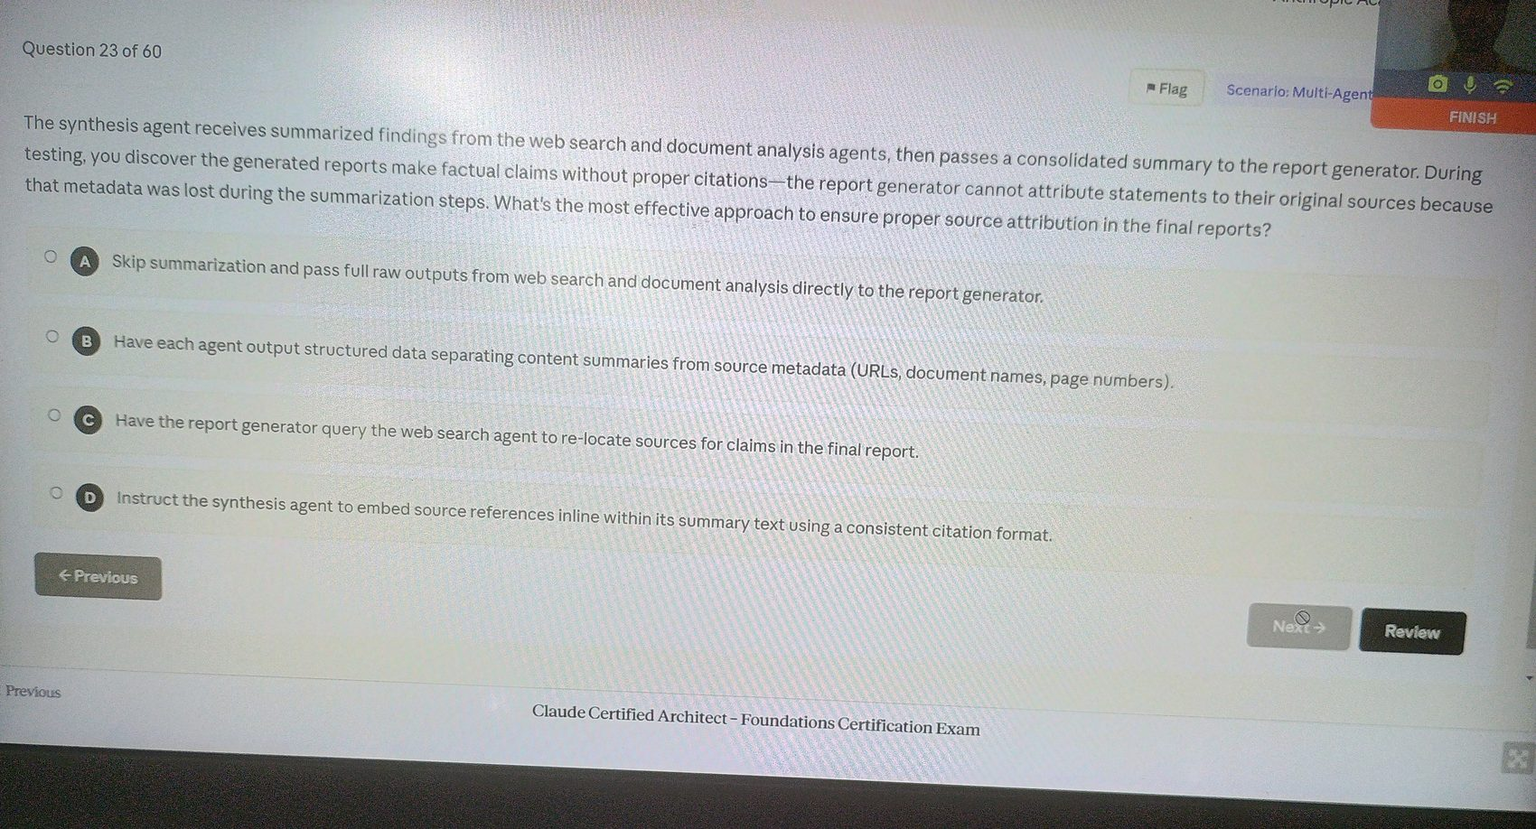

Image 26 - Question 24
Source image: image-1776407150470.jpg
Correct option: "A. Include the complete findings from both subagents directly in the synthesis subagent's prompt."
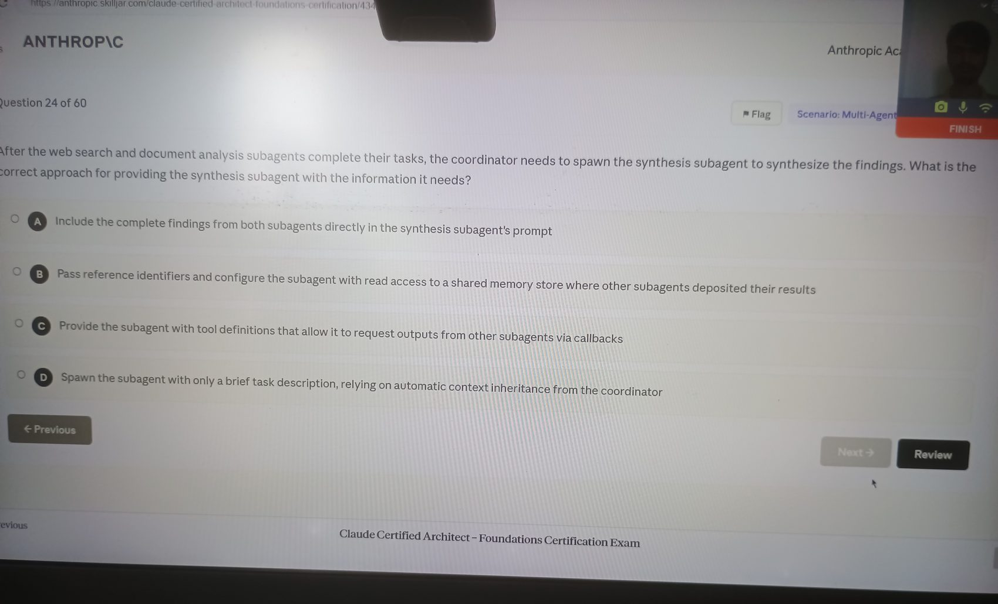

Image 27 - Question 25
Source image: image-1776407172027.jpg
Correct option: "A. The coordinator's allowedTools configuration doesn't include Task, so it cannot invoke the tool required to spawn subagents."
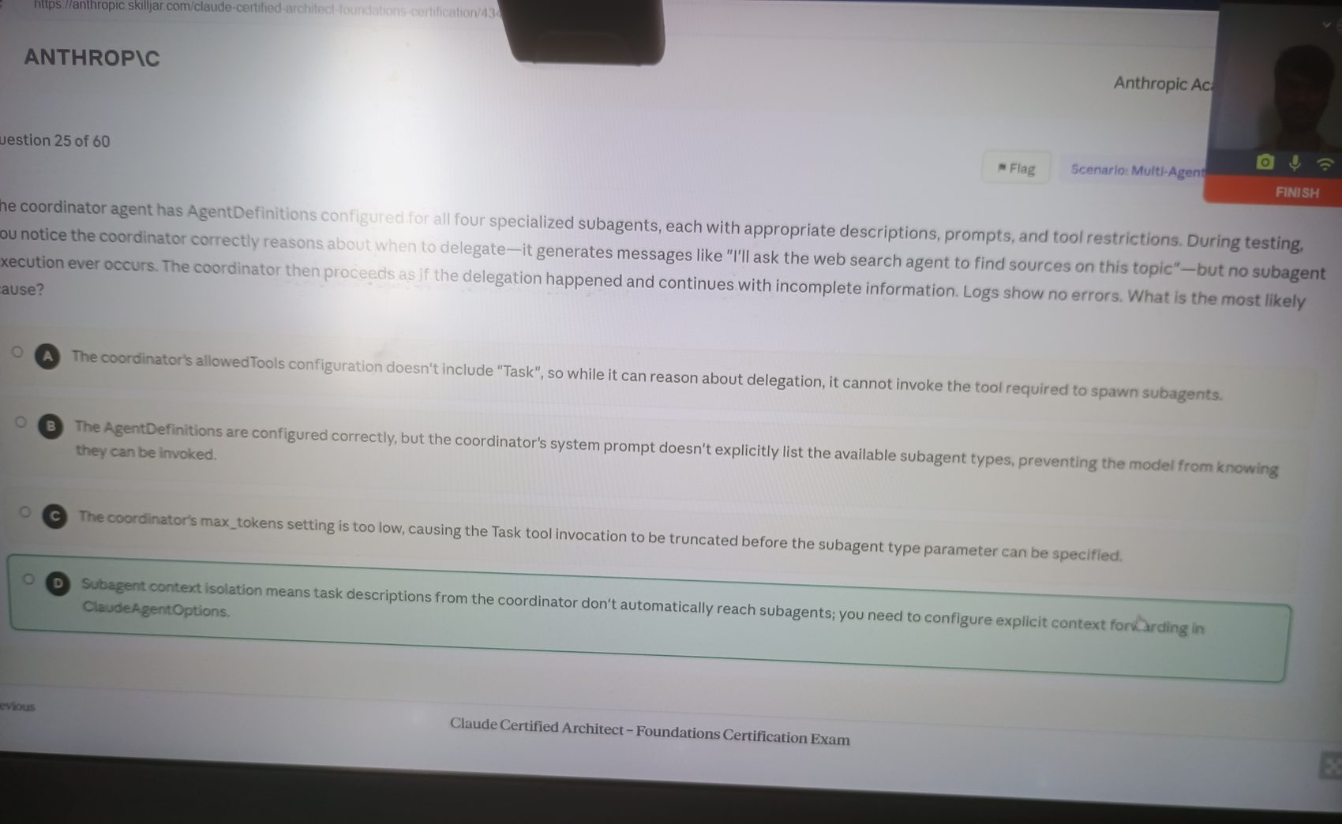

Image 28 - Question 26
Source image: image-1776407190198.jpg
Correct option: "B. The coordinator agent receives the web search agent's output and includes relevant findings in the prompt when invoking the document analysis agent."
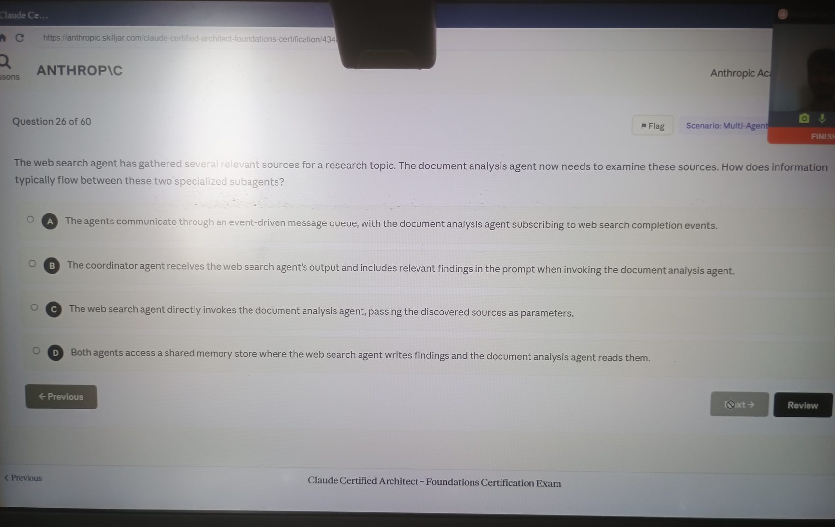

Image 29 - Question 27
Source image: image-1776407208293.jpg
Correct option: "D. Have the coordinator spawn parallel document analysis subagents, each handling a subset of precedents, then aggregate results before synthesis."
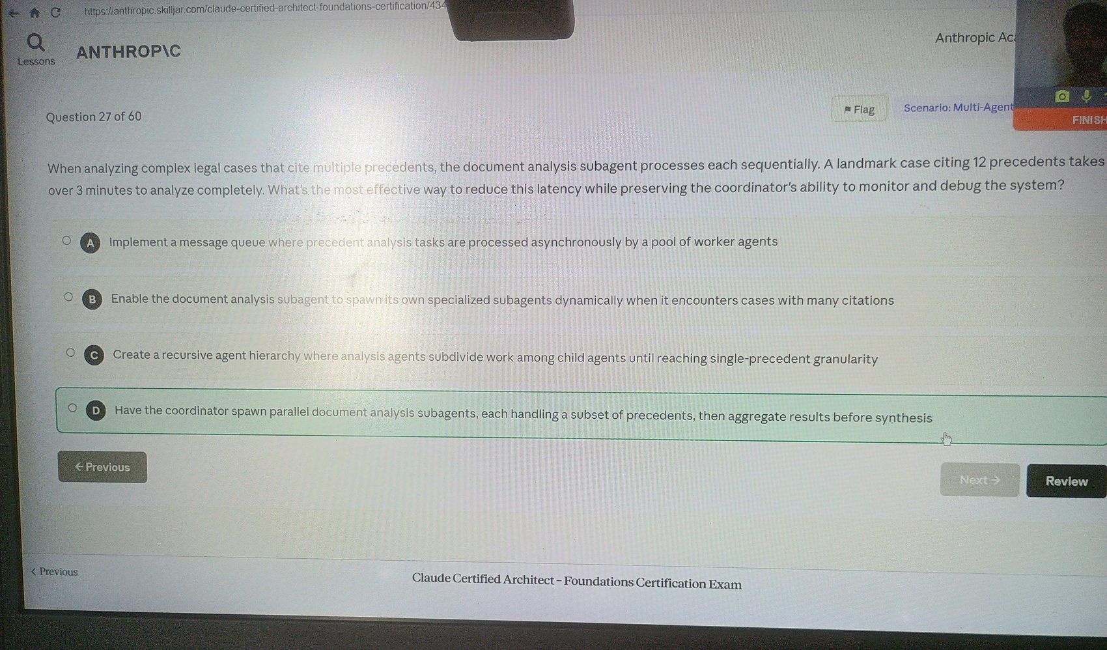

Image 30 - Question 28
Source image: image-1776407229660.jpg
Correct option: "C. Choosing from 18 tools instead of 4-5 relevant ones increases decision complexity beyond reliable selection thresholds."
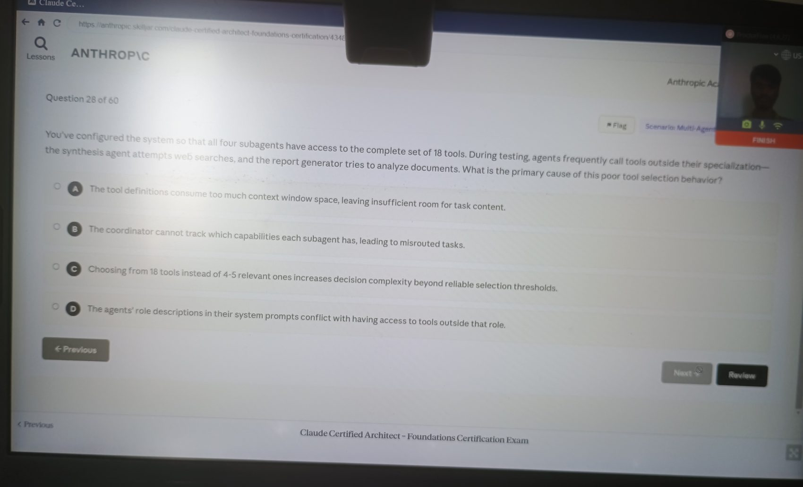

Image 31 - Question 29
Source image: image-1776407249465.jpg
Correct option: "C. Split the generic tool into purpose-specific tools with defined input/output contracts."
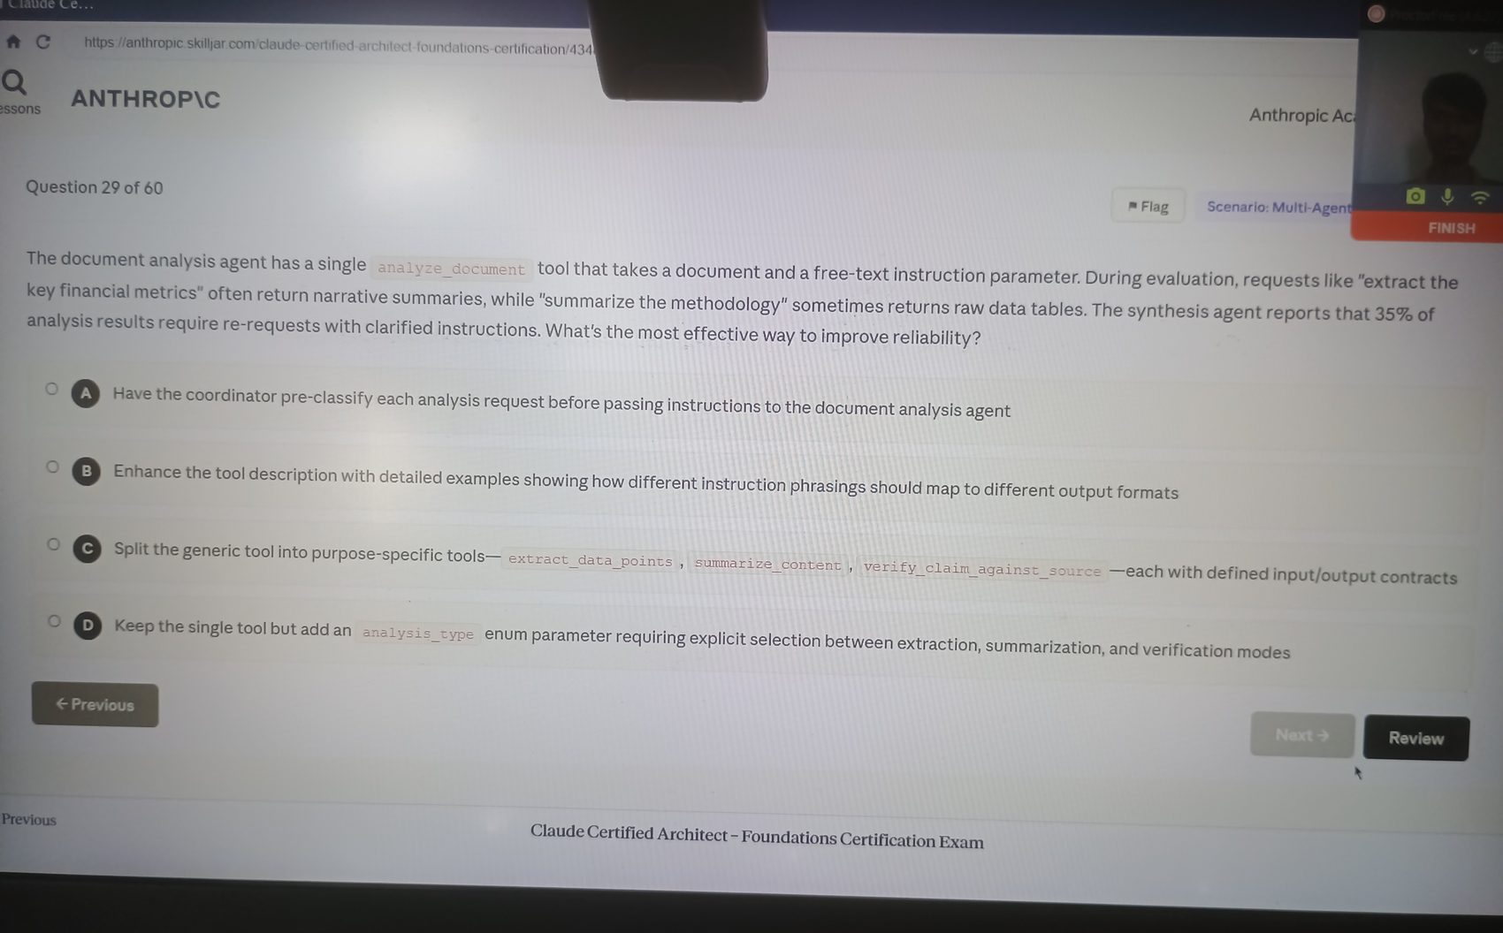

Image 32 - Question 30
Source image: image-1776407267483.jpg
Correct option: "B. Have the coordinator handle straightforward summarization requests directly using its existing context, reserving subagent spawning for complex analysis."
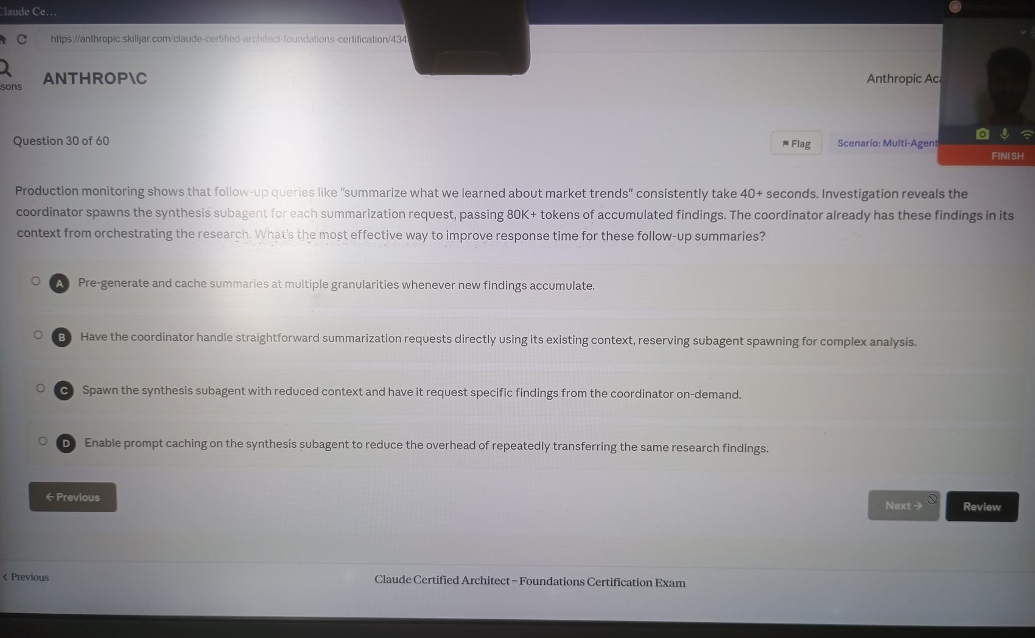

Image 33 - Question 31
Source image: image-1776407312078.jpg
Correct option: "A. The conversation history isn't being passed in subsequent API requests."
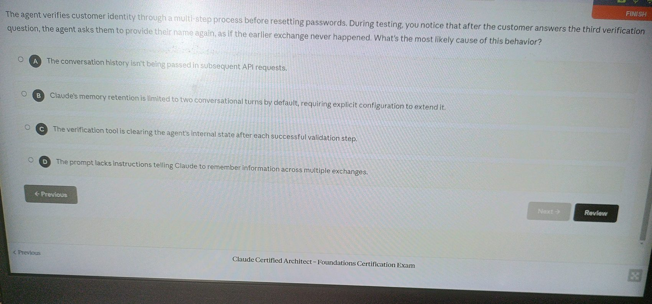

Image 34 - Question 32
Source image: image-1776407334916.jpg
Correct option: "C. Return structured error responses with retriable: false for business errors and a customer-friendly explanation for Claude to use."
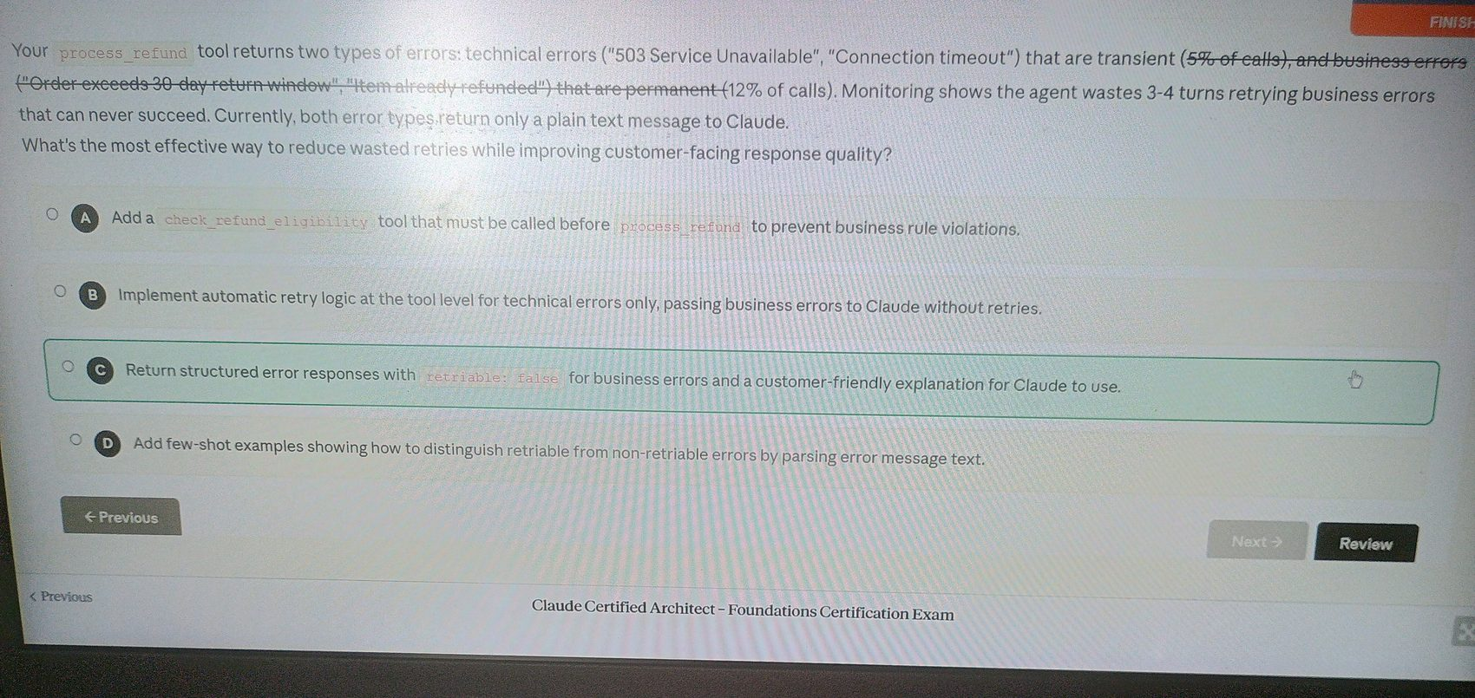

Image 35 - Question 33
Source image: image-1776407356566.jpg
Correct option: "D. A structured summary: customer ID, root cause, refund amount, and recommended action."
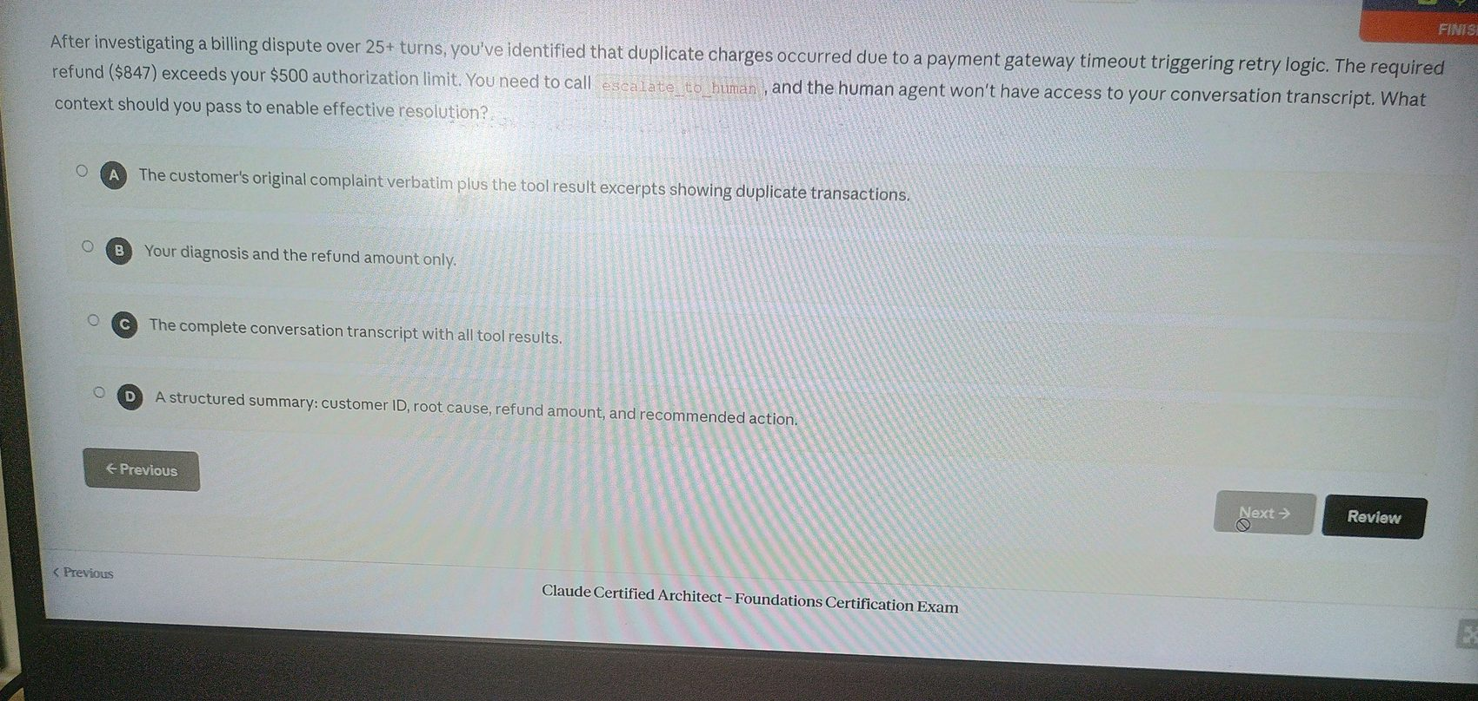

Image 36 - Question 34
Source image: image-1776407386258.jpg
Correct option: "C. Return the error message in the tool result content with the isError flag set to true."
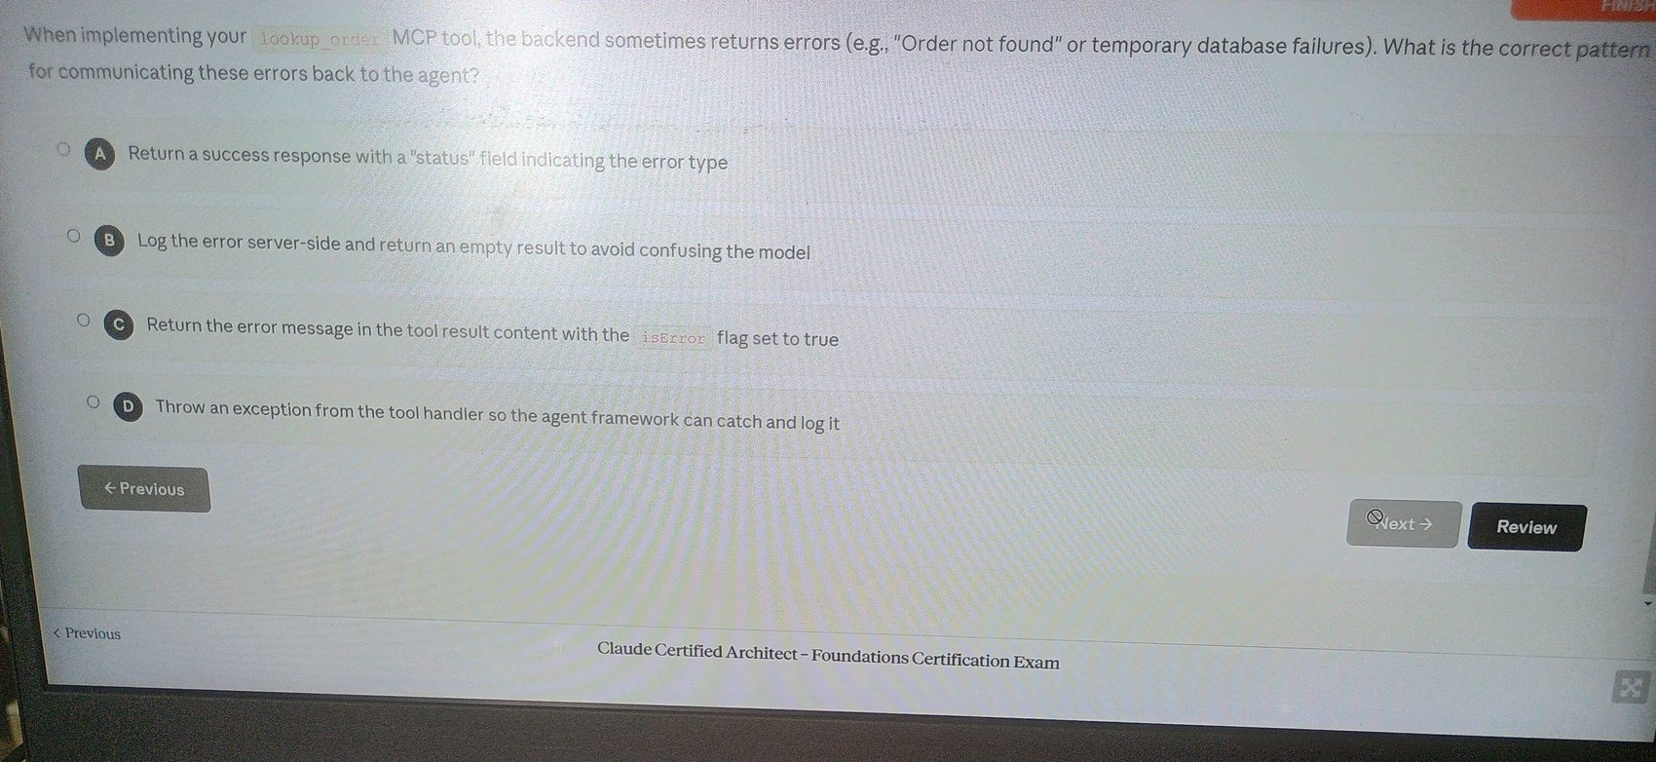

Image 37 - Question 35
Source image: image-1776407430275.jpg
Correct option: "D. Explain the billing, confirm refund eligibility, acknowledge the system issue preventing immediate processing, and offer escalation or retry later."
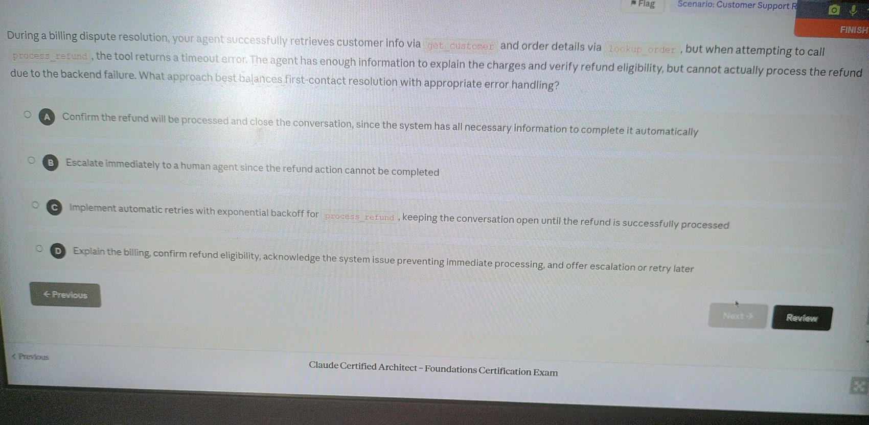

Image 38 - Question 36
Source image: image-1776407453734.jpg
Correct option: "C. Implement a hook to intercept tool calls; when the refund process amount exceeds $500, block it and invoke human escalation."
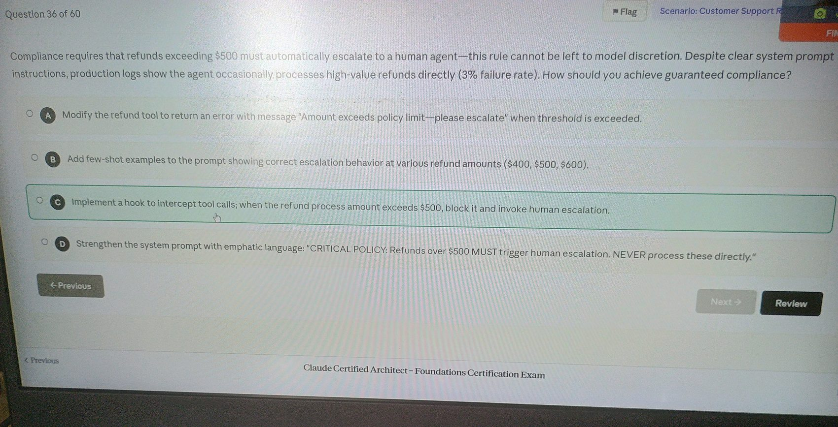

Image 39 - Question 37
Source image: image-1776407470122.jpg
Correct option: "B. Instruct the agent to escalate when the customer requests a human, when the issue requires policy exceptions, or when the agent cannot make meaningful progress."
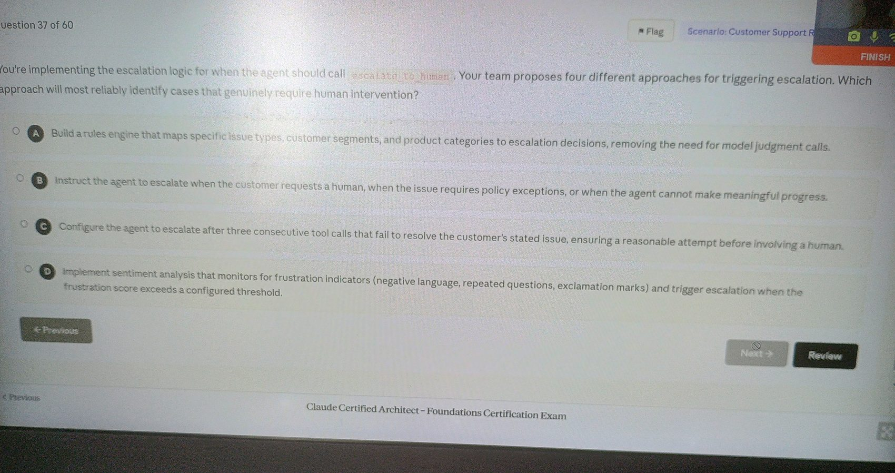

Image 40 - Question 38
Source image: image-1776407493585.jpg
Correct option: "D. Enhance error responses with structured metadata, including errorCategory, isRetryable, and a description of what caused the failure."
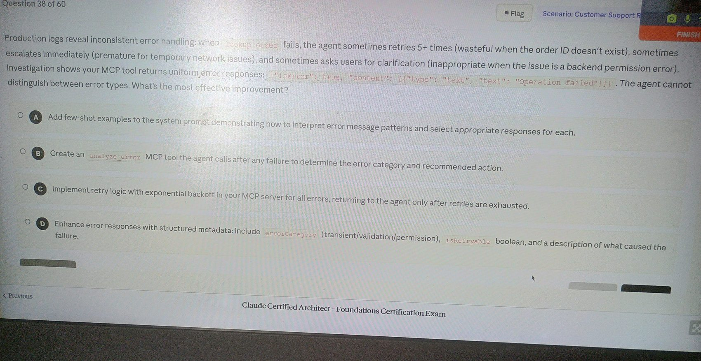

Image 41 - Question 39
Source image: image-1776407515978.jpg
Correct option: "A. Extract and persist structured issue data into a separate context layer."
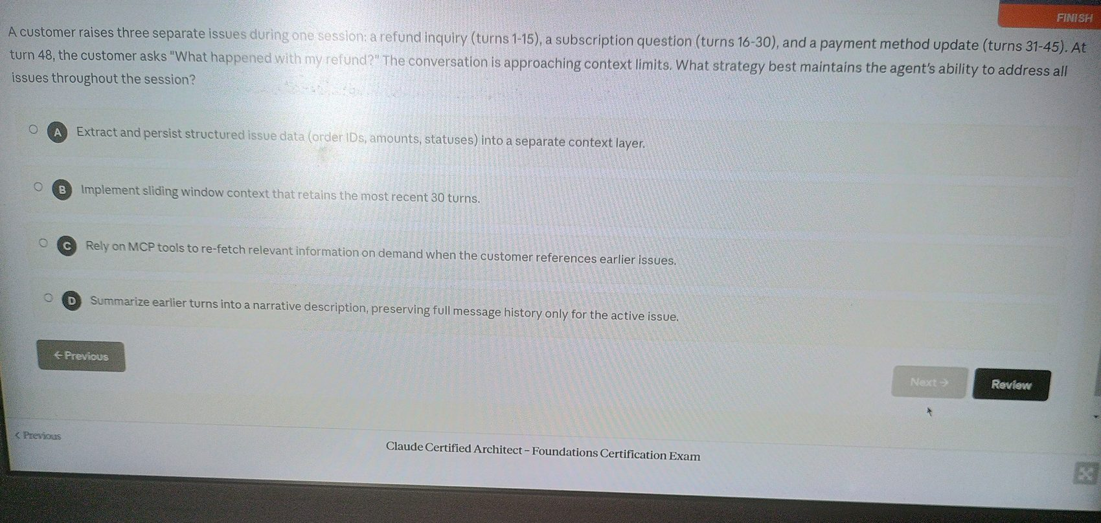

Image 42 - Question 40
Source image: image-1776407601117.jpg
Correct option: "C. Start a new session, inject a structured summary of the previous interaction, then make fresh tool calls before engaging."
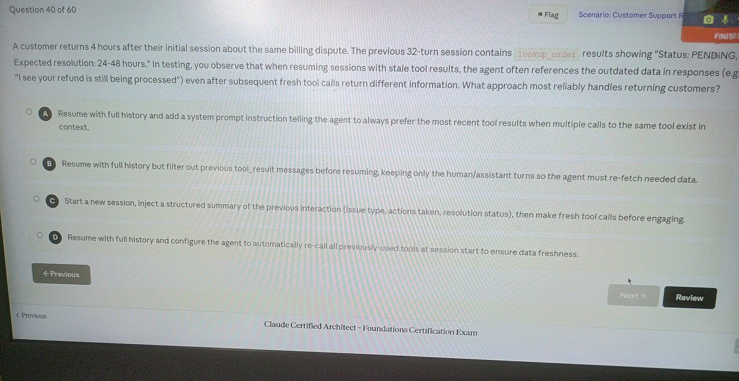

Image 43 - Question 41
Source image: image-1776407649920.jpg
Correct option: "B. Immediately call escalate_to_human with the conversation history."
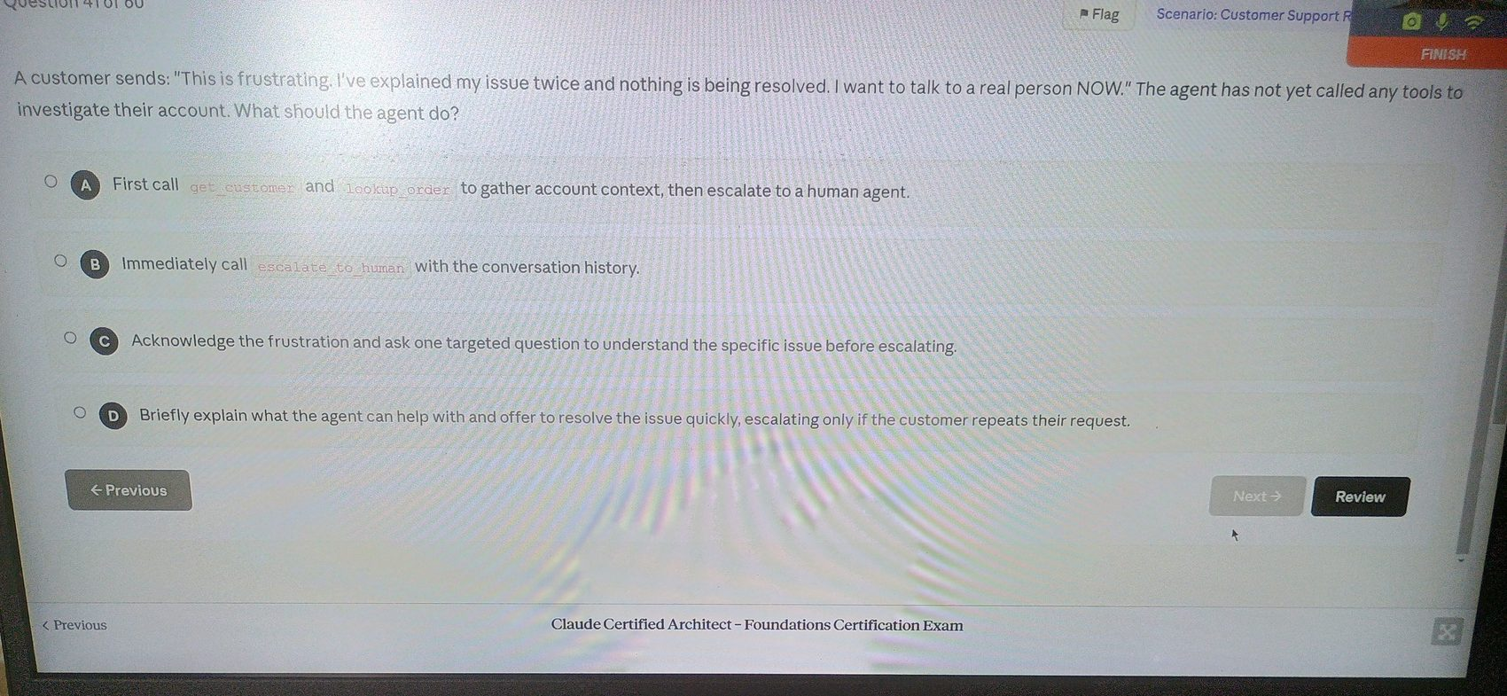

Image 44 - Question 41
Source image: image-1776407689886.jpg
Correct option: "B. Immediately call escalate_to_human with the conversation history."
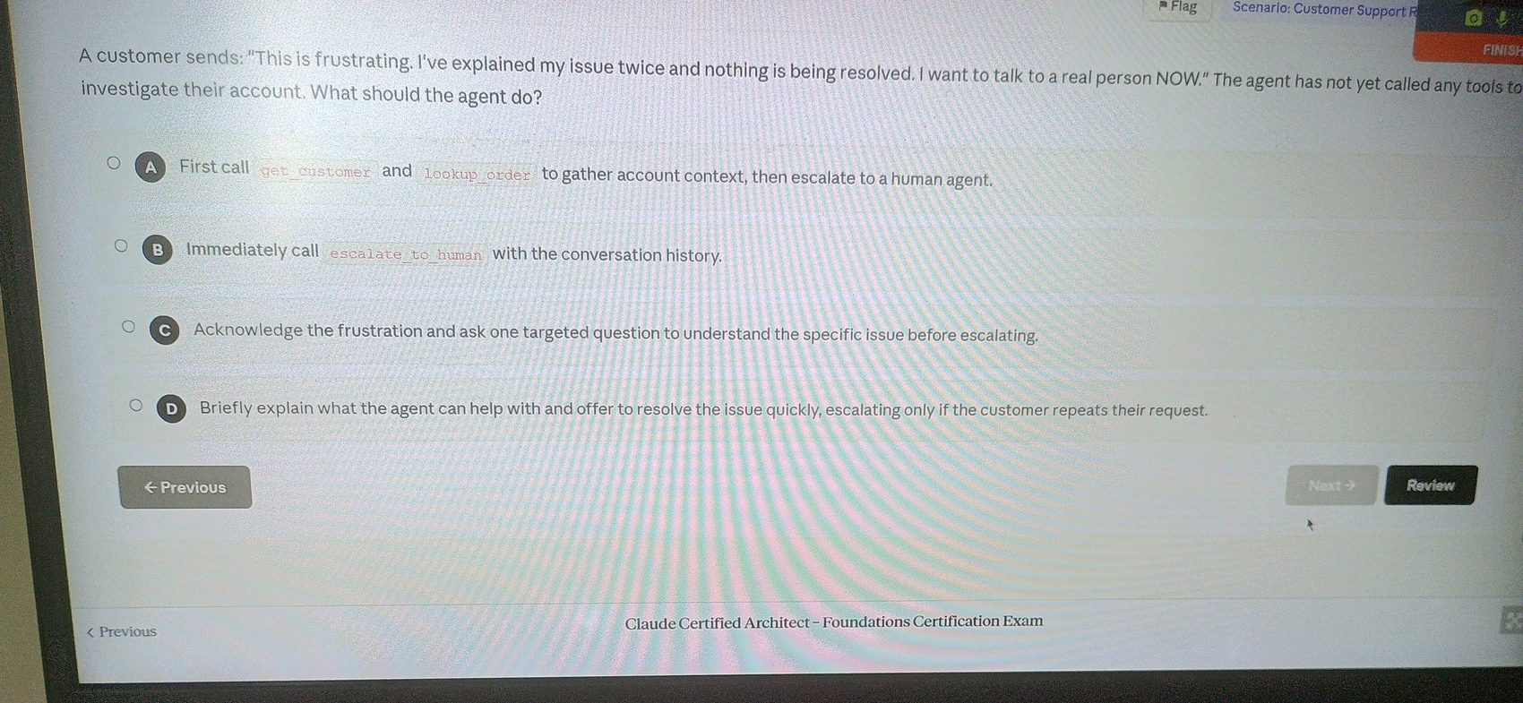

Image 45 - Question 42
Source image: image-1776407710277.jpg
Correct option: "D. The order details are added to the conversation and the model reasons about which action to take."
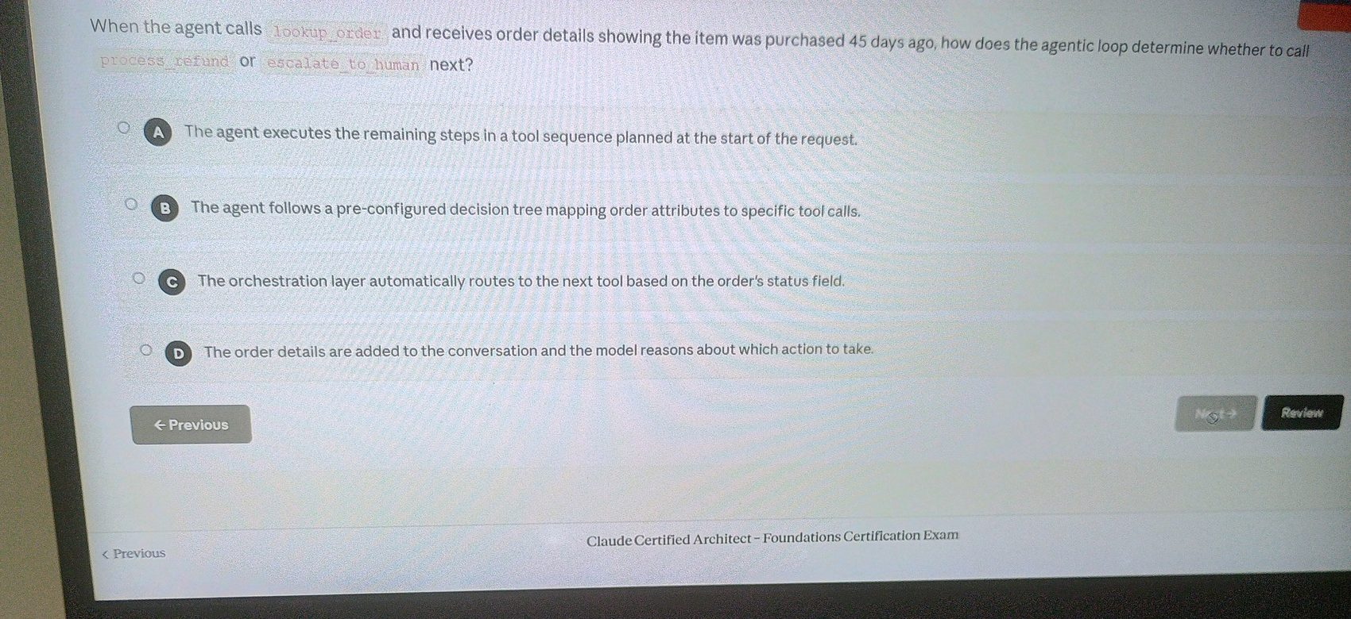

Image 46 - Question 43
Source image: image-1776407729266.jpg
Correct option: "D. Extract only return-relevant fields from each existing order response, removing verbose details."
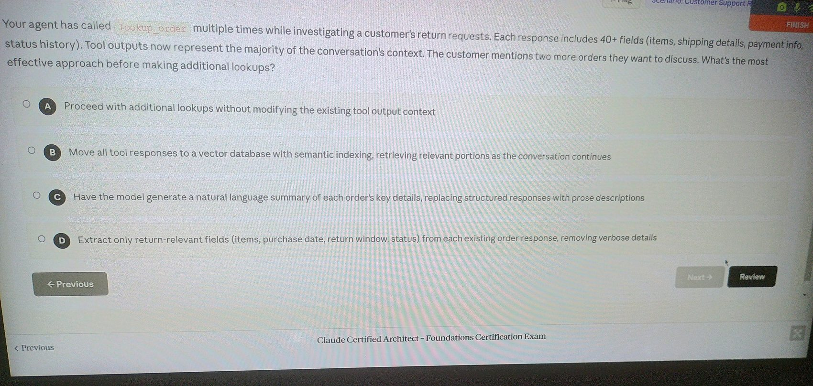

Image 47 - Question 43
Source image: image-1776407793629.jpg
Correct option: "D. Extract only return-relevant fields from each existing order response, removing verbose details."
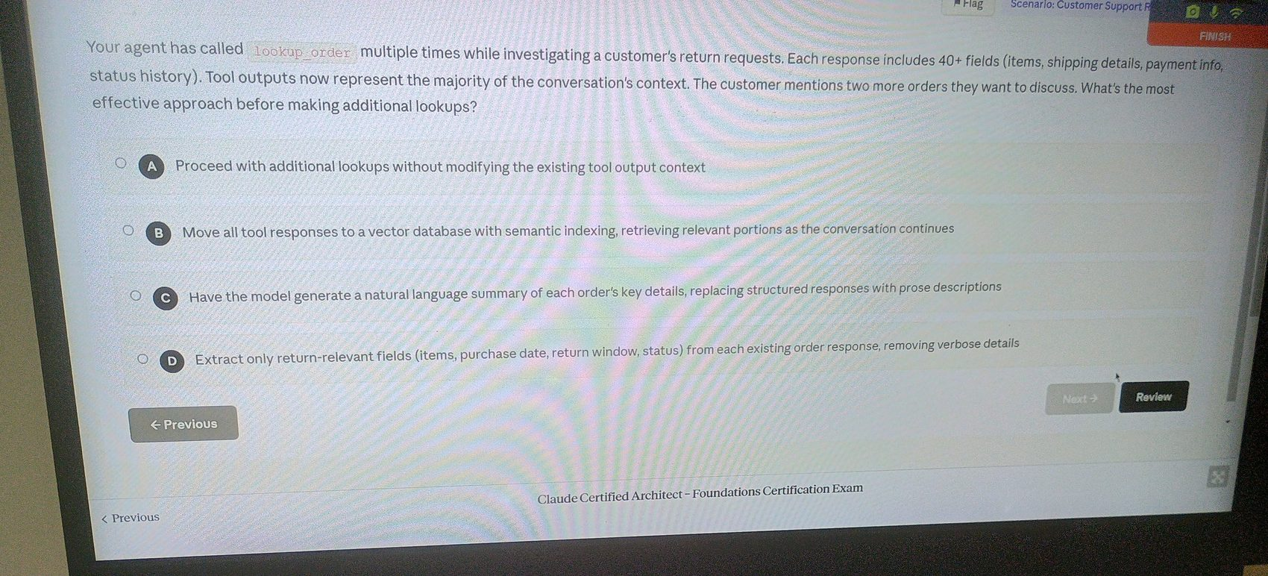

Image 48 - Question 44
Source image: image-1776407817687.jpg
Correct option: "D. Compile a structured handoff with customer details, order info, and the identified issue before calling escalate_to_human."
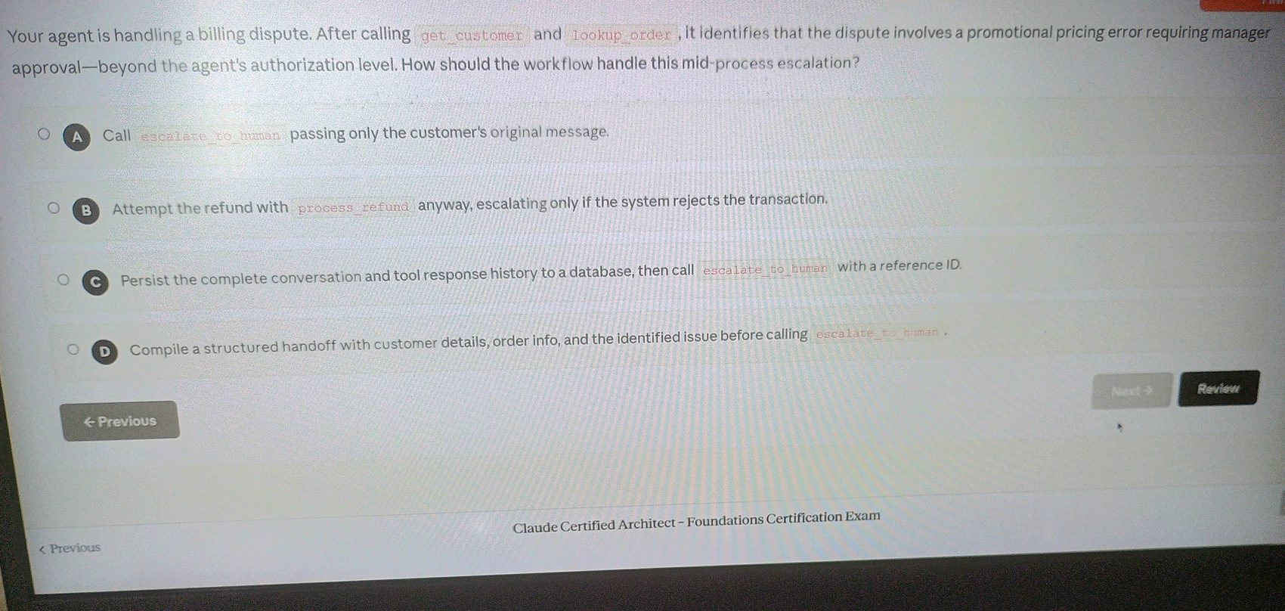

Image 49 - Question 44
Source image: image-1776407829355.jpg
Correct option: "D. Compile a structured handoff with customer details, order info, and the identified issue before calling escalate_to_human."
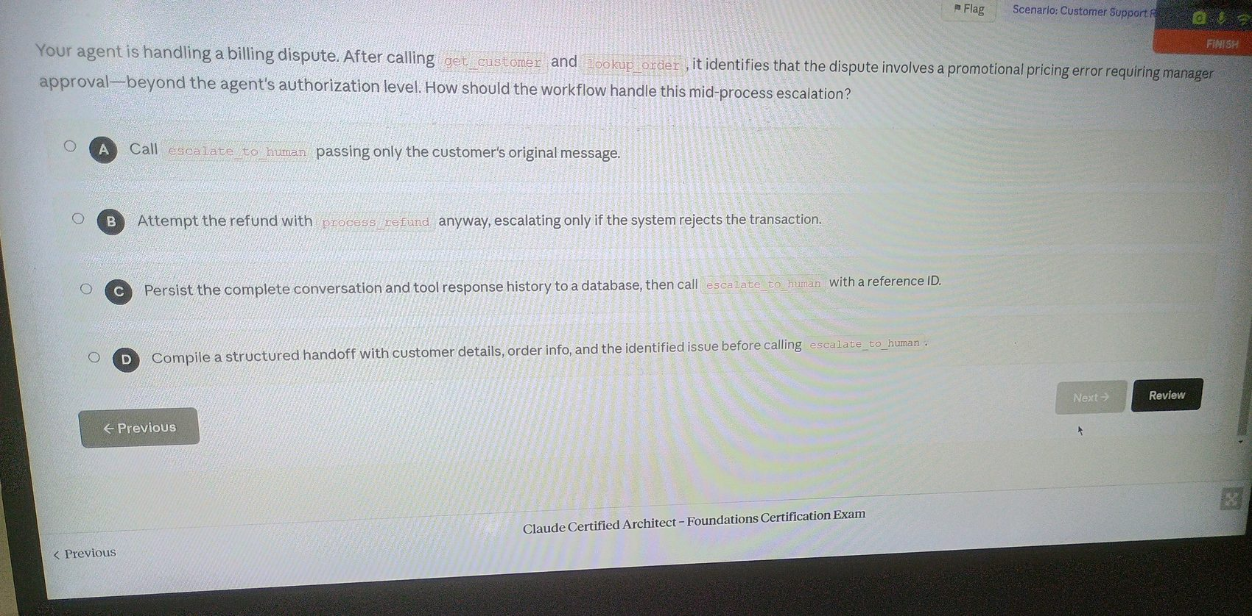

Image 50 - Question 45
Source image: image-1776407857190.jpg
Correct option: "C. Acknowledge frustration, inform them this is resolvable now, and offer to complete it or escalate."
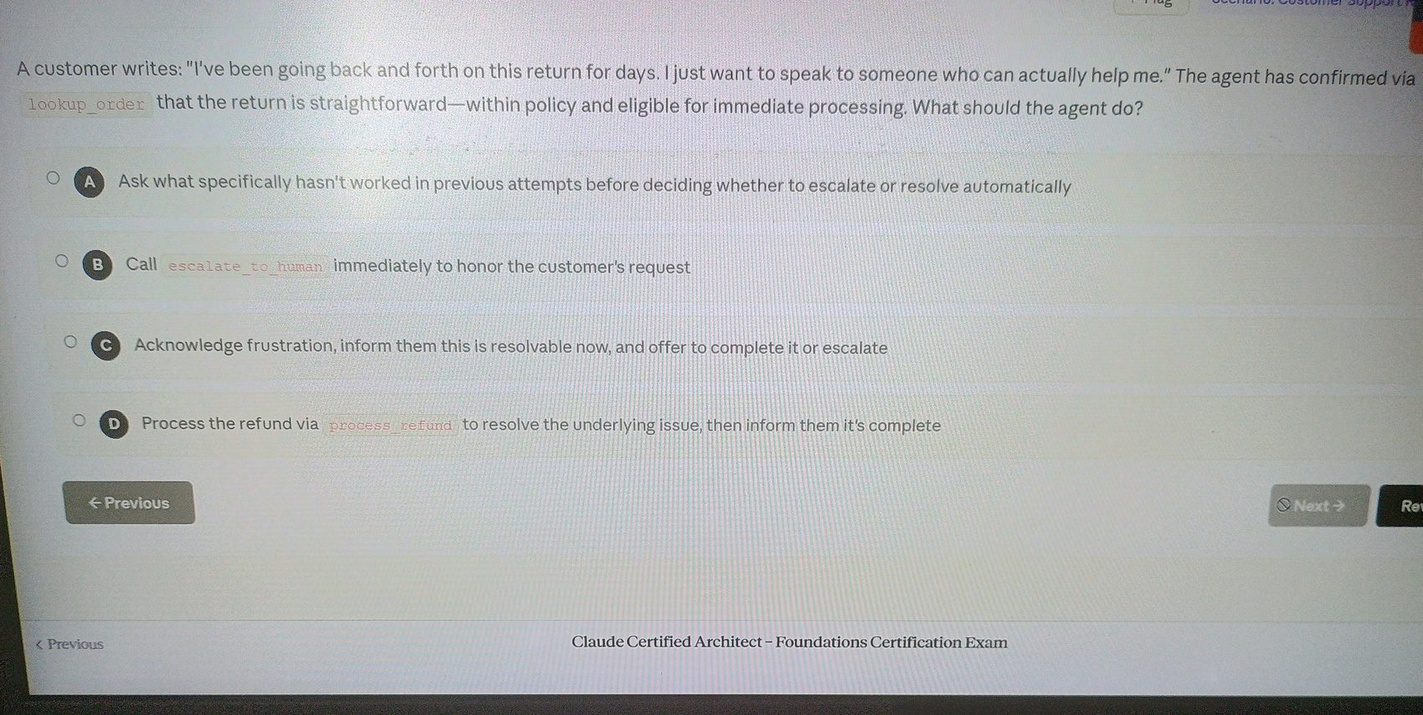

Image 51 - Question 46
Source image: image-1776407877002.jpg
Correct option: "C. Add few-shot examples showing complete input-output pairs with standardized material description formats."
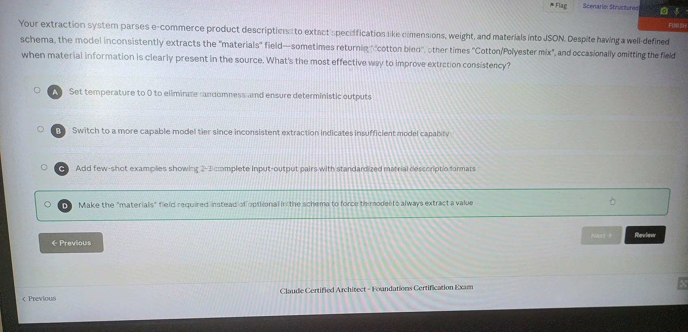

Image 52 - Question 47
Source image: image-1776407894588.jpg
Correct option: "D. Split lengthy transcripts into chunks, extract from each chunk separately, then merge and deduplicate the results."
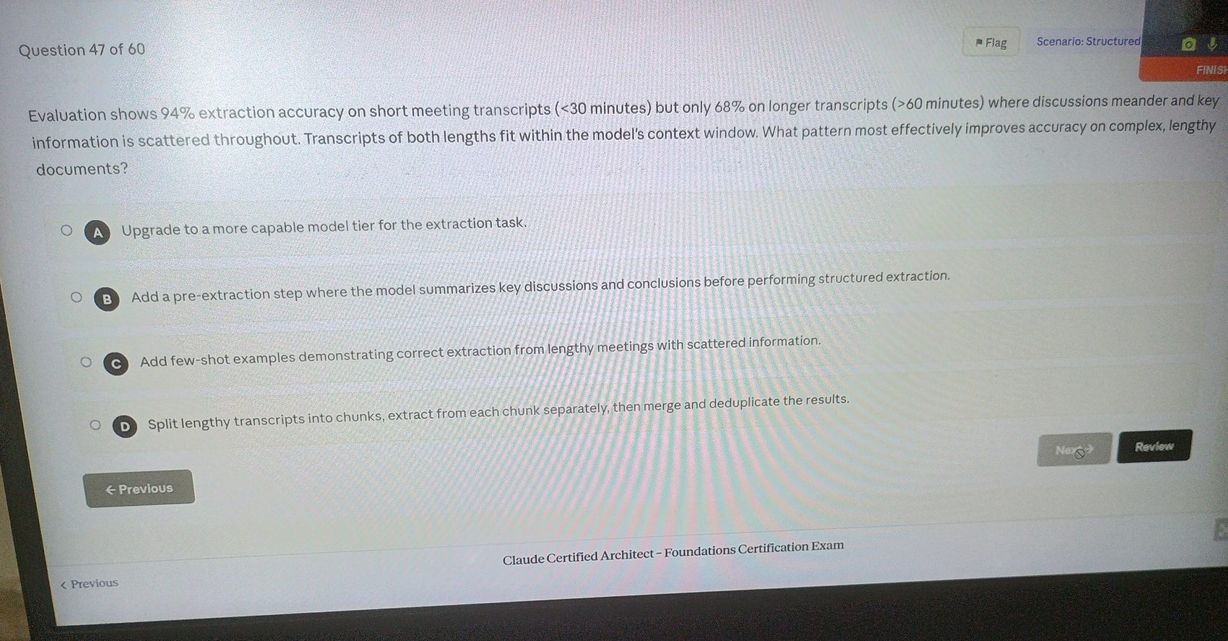

Image 53 - Question 48
Source image: image-1776407913797.jpg
Correct option: "C. Define a strict output schema and include format normalization rules in your prompt."
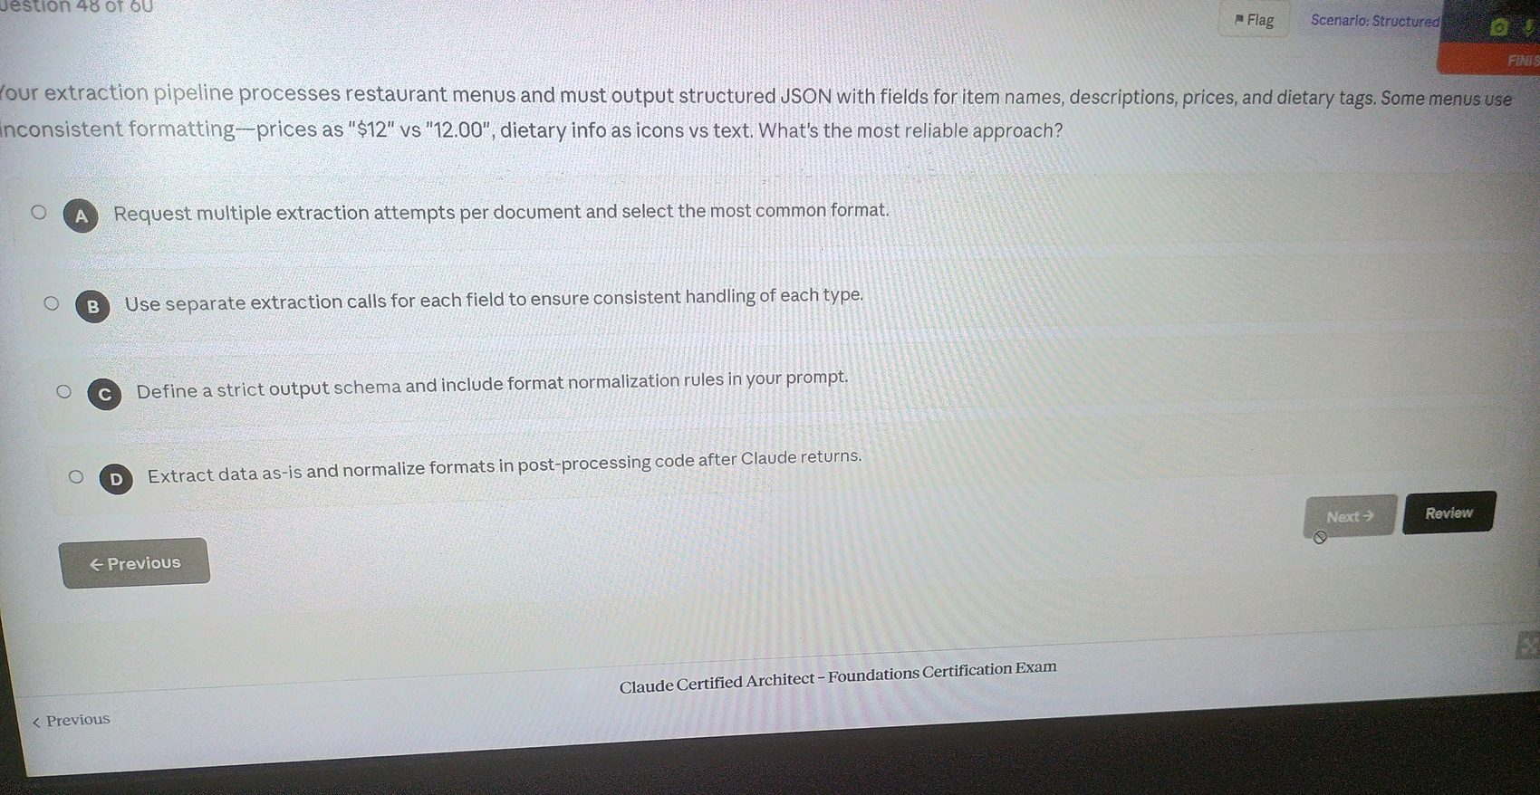

Image 54 - Question 49
Source image: image-1776407937557.jpg
Correct option: "B. Add constraints: extract 10-20 skills maximum, one skill per entry, only explicitly named skills."
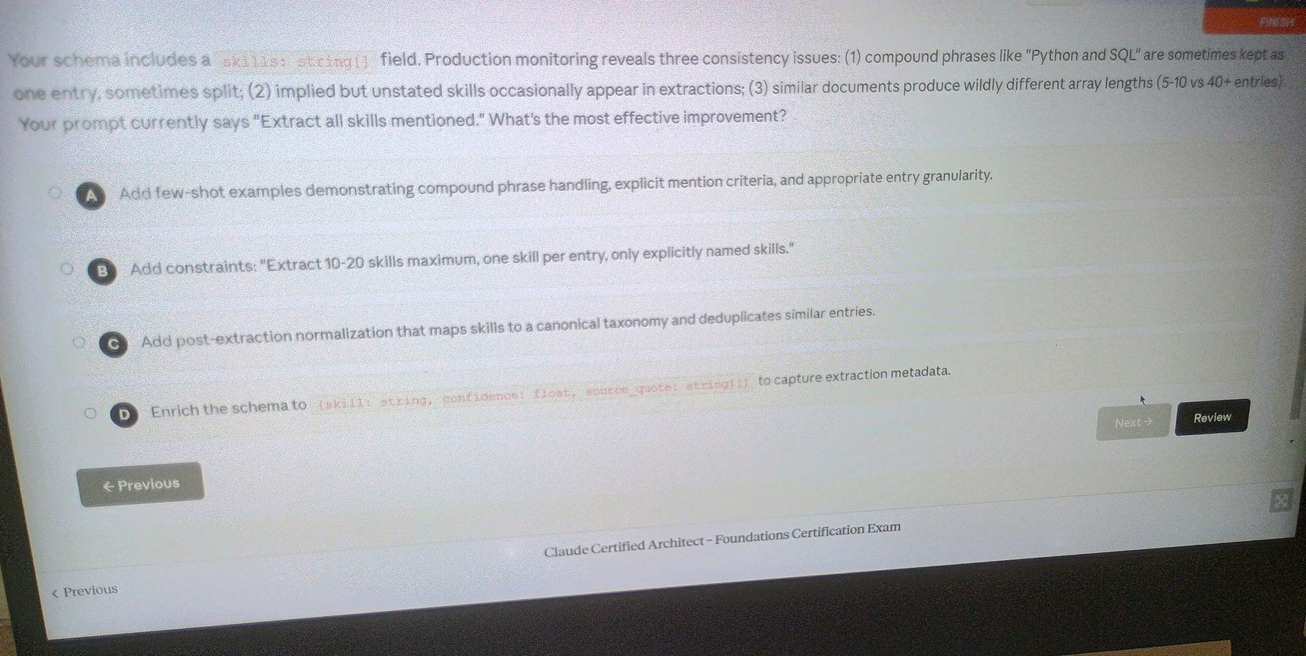

Image 55 - Question 50
Source image: image-1776407956713.jpg
Correct option: "D. Change fields that may not exist in source documents from required to optional, allowing the model to omit them."
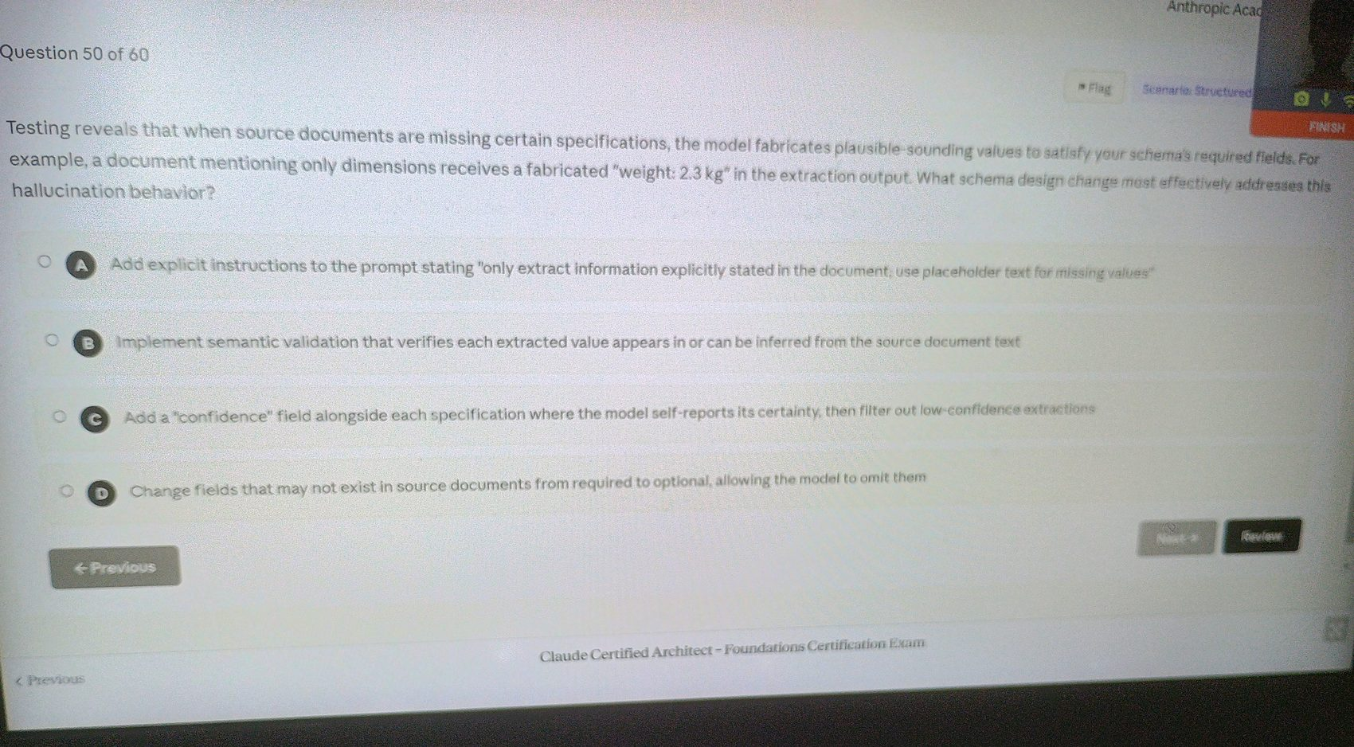

Image 56 - Question 52
Source image: image-1776408110813.jpg
Correct option: "B. Add a preliminary classification call, then make a second call with tool_choice forced to the identified extraction tool."
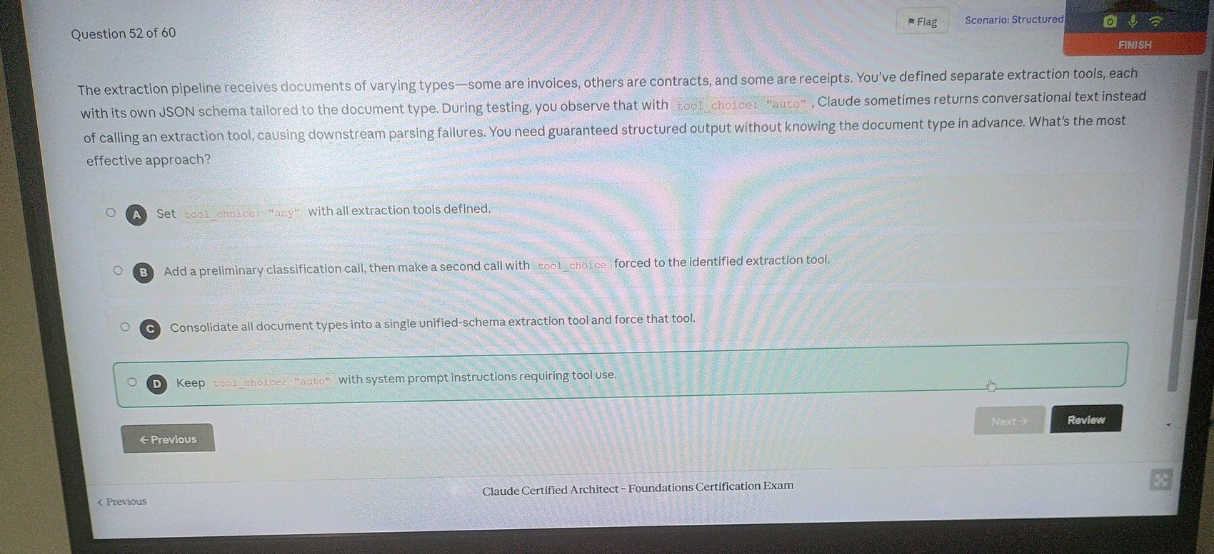

Image 57 - Question 52
Source image: image-1776408132122.jpg
Correct option: "B. Add a preliminary classification call, then make a second call with tool_choice forced to the identified extraction tool."
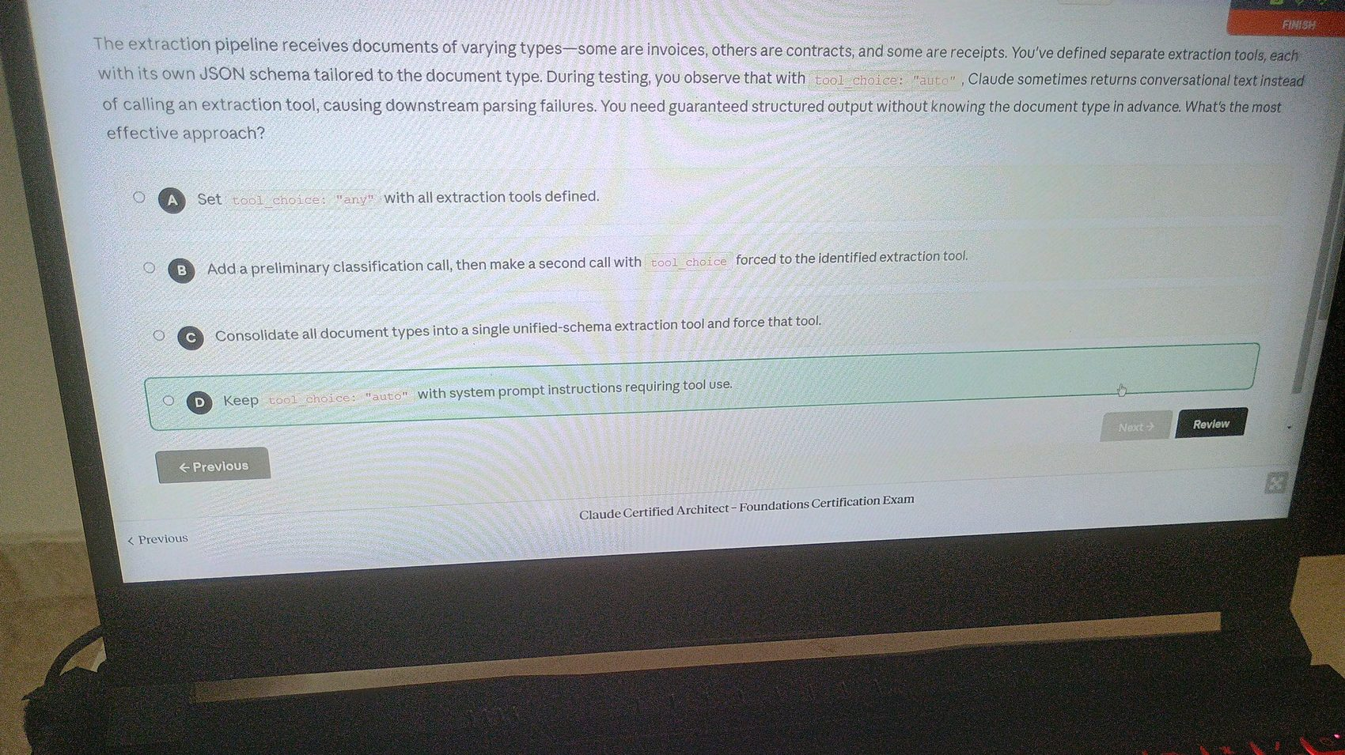

Image 58 - Question 54
Source image: image-1776408227147.jpg
Correct option: "C. Define a tool with an input schema matching your required JSON structure and extract the data from Claude's tool_use response."
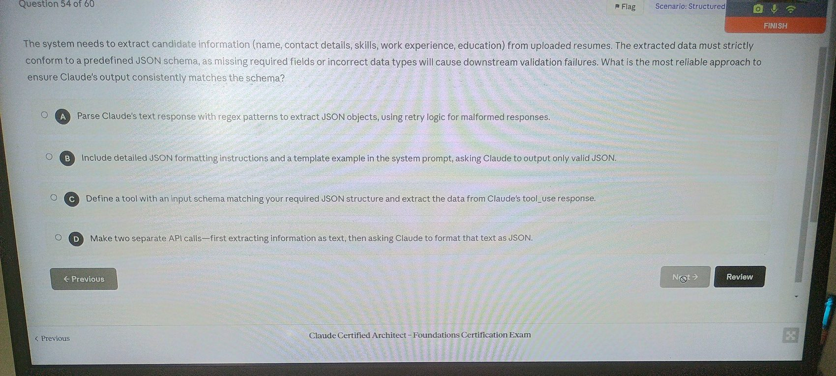

Image 59 - Question 55
Source image: image-1776408292614.jpg
Correct option: "C. Change property_type from an enum to a free-form string and implement a normalization step in post-processing."
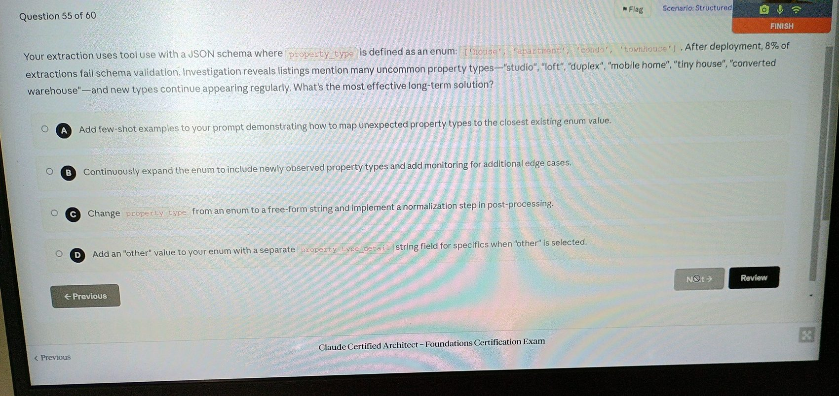

Image 60 - Question 56
Source image: image-1776408349396.jpg
Correct option: "D. Include extraction instructions specifying to prefer values from the detailed specs table when multiple values exist, keeping the single-value schema."
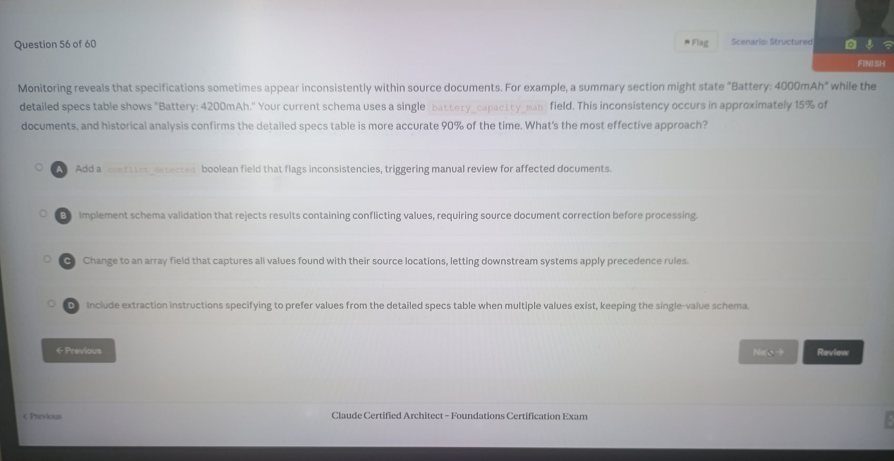

Image 61 - Question 56
Source image: image-1776408396464.jpg
Correct option: "D. Include extraction instructions specifying to prefer values from the detailed specs table when multiple values exist, keeping the single-value schema."
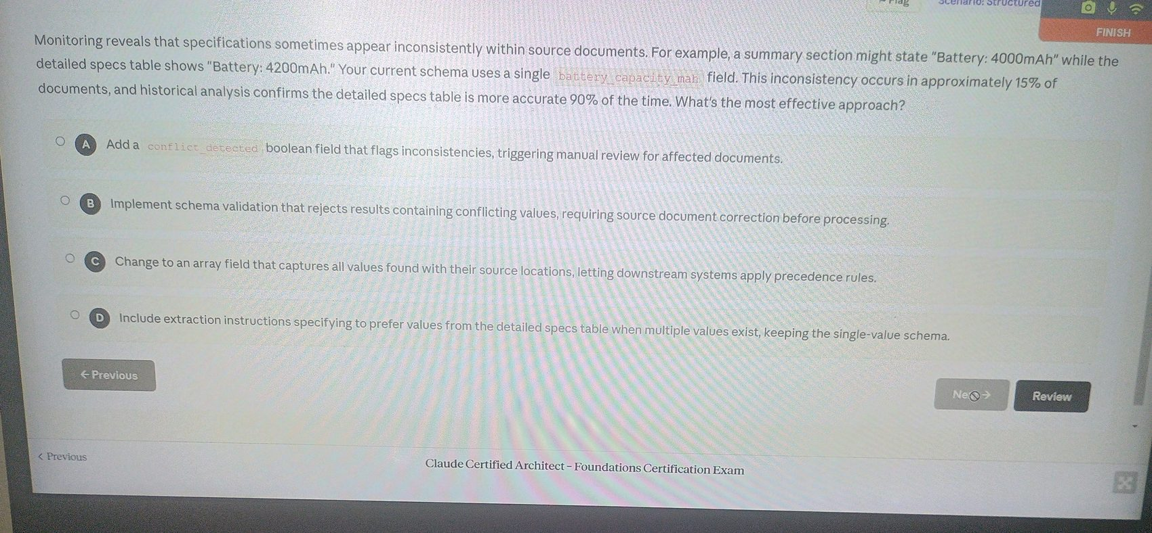

Image 62 - Question 57
Source image: image-1776408432274.jpg
Correct option: "D. Set tool_choice to extract_metadata and process the enrichment requests in subsequent turns after receiving the extracted metadata."
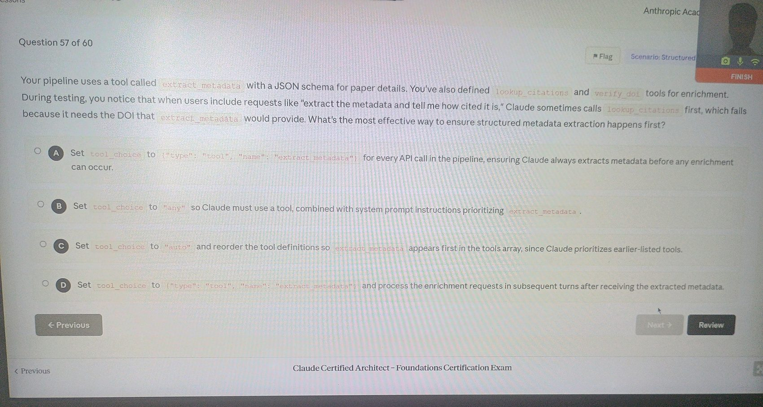

Image 63 - Question 57
Source image: image-1776408492099.jpg
Correct option: "D. Set tool_choice to extract_metadata and process the enrichment requests in subsequent turns after receiving the extracted metadata."
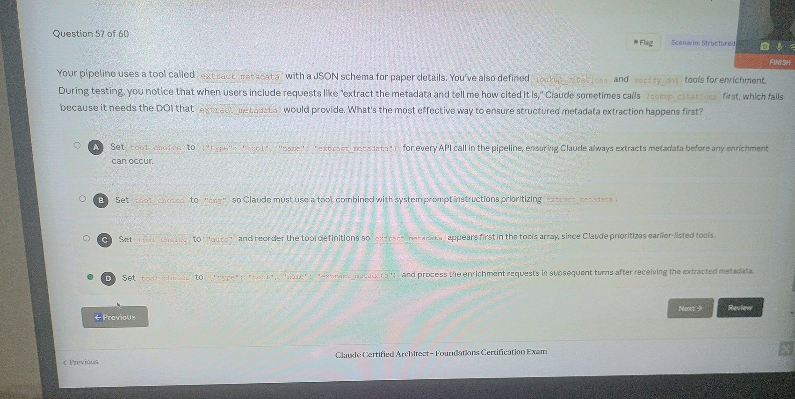

Image 64 - Question 58
Source image: image-1776408549775.jpg
Correct option: "B. Add prompt instructions to return null for any field where information is not directly stated in the source."
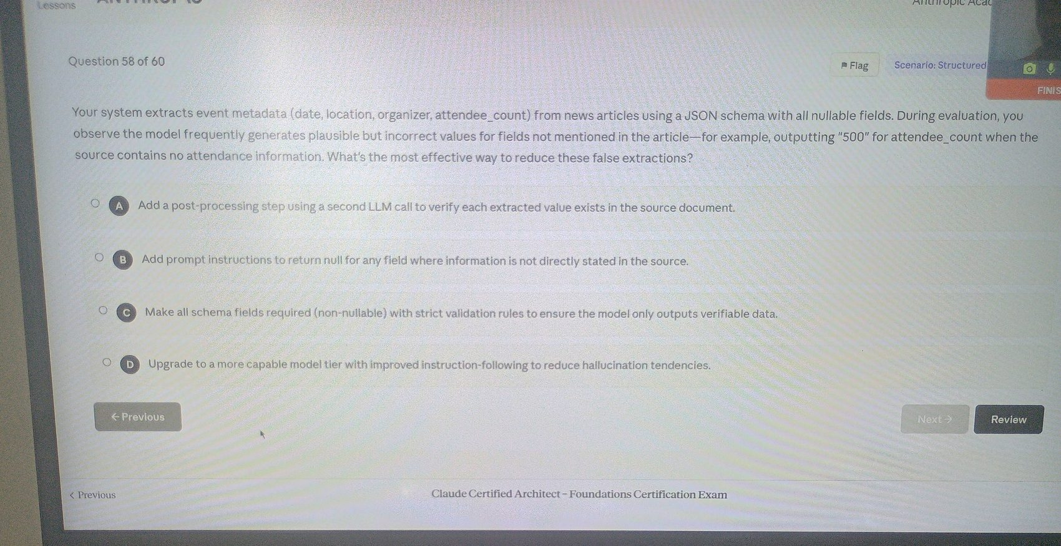

Image 65 - Question 59
Source image: image-1776408584729.jpg
Correct option: "D. Define a tool with your target schema as input parameters and have Claude call it with the extracted data."
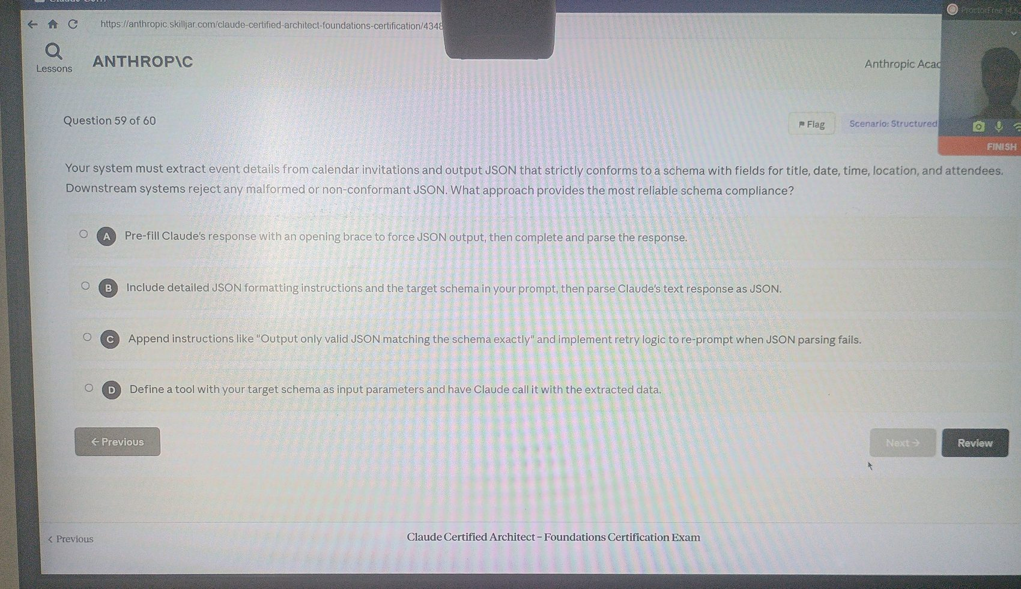

Image 66 - Question 60
Source image: image-1776408625726.jpg
Correct option: "B. Define a tool with a JSON schema specifying the expected structure, using tool_use to constrain Claude's output to schema-compliant JSON."
